Neural mechanisms in processing of emotion in real and virtual faces using functional-near infrared spectroscopy (fNIRS)

by

Dylan Rapanan

A thesis submitted to the

School of Graduate and Postdoctoral Studies

in partial fulfillment of the requirements for the degree of

### Masters of Science in Computer Science

Faculty of Science Ontario Tech University Oshawa, Ontario, Canada

© Dylan Rapanan 2025

## Abstract

As avatars permeate social media, gaming, and telecommunications, understanding how the brain reads emotions from virtual faces is increasingly important. We recorded func- tional near-infrared spectroscopy (fNIRS) data from adults viewing real photographs and matched computer-generated faces expressing Anger, Disgust, Fear, Joy, Sadness, Sur- prise, or Neutral (control). General-linear-model mapping revealed higher activation in virtual faces in the left occipital region, and higher activation in Neutral and Surprise compared to the other emotions in parietal and occipital regions. Functional-connectivity analysis revealed higher connectivity in real faces across the brain, and higher connectiv- ity across the brain in Anger and Fear compared to the other emotions. Collectively, the results demonstrate differences in activation in occipital areas, and differential process- ing of face and emotion types across the whole brain. These neural signatures provide quantitative targets for refining the realism and emotional efficacy of digital characters in virtual and augmented environments.

## Acknowledgements

** Put your Acknowledgements here. ***

# Contents

|  |  |
| --- | --- |
| **Abstract**  **Acknowledgment**  **1 Introduction** | **ii**  **iii 1** |
| **2 Methodology** | **2** |
| 2.1 Participants . . . . . . . . . . . . . . . . . . . . . . . . . . . . . . . . . . | 2 |
| 2.2 Stimuli and apparatus . . . . . . . . . . . . . . . . . . . . . . . . . . . . | 4 |
| 2.2.1 Stimuli . . . . . . . . . . . . . . . . . . . . . . . . . . . . . . . . . | 4 |
| 2.2.2 Apparatus . . . . . . . . . . . . . . . . . . . . . . . . . . . . . . . | 4 |
| 2.3 Design and procedure . . . . . . . . . . . . . . . . . . . . . . . . . . . . . | 6 |
| 2.3.1 Design . . . . . . . . . . . . . . . . . . . . . . . . . . . . . . . . . | 6 |
| 2.3.2 Procedure . . . . . . . . . . . . . . . . . . . . . . . . . . . . . . . | 7 |
| 2.4 Analyses . . . . . . . . . . . . . . . . . . . . . . . . . . . . . . . . . . . . | 8 |
| 2.4.1 fNIRS preprocessing . . . . . . . . . . . . . . . . . . . . . . . . . | 9 |
| 2.4.2 Activation magnitude with General Linear Model (GLM) . . . . . | 10 |
| Design Matrix . . . . . . . . . . . . . . . . . . . . . . . . . . . . . | 11 |
| Contrast Computation . . . . . . . . . . . . . . . . . . . . . . . . | 12 |
| 2.4.3 Network mapping with Functional Connectivity Analysis . . . . . | 13 |
| Paired Sample t-tests . . . . . . . . . . . . . . . . . . . . . . . . . | 14 |

ROI Chord Plots 14

* + 1. Memory Task Analysis 14

1. Results 16
   1. Activation magnitude 16
   2. Functional Connectivity Results 20
   3. Memory Task Results 25
2. Discussion 27
   1. Limitations and Future Directions 27
   2. Conclusion 27

Bibliography 27

Appendix 32

A GLM Contrasts 33

1. Functional Connectivity Contrasts 38
2. Memory Task 46
   1. ANOVA Results 46
   2. Memory Task No Response Distribution 47

**List of Tables**

* 1. Table of contrast results from the GLM analysis. 33
  2. Ratio of positive to negative *t*-values for each contrast. The ratio is cal- culated as Ratio = (Number of Positive *t*-values - Number of Negative *t*-values) / (Number of Positive *t*-values + Number of Negative *t*-values). For condition1 *>* condition2, a positive ratio indicates that condition1 has more positive *t*-values than condition2, while a negative ratio indicates the

opposite. 40

* 1. Two-way ANOVA results for the effect of Face Type and Emotion and

their interaction on the correct responses. 46

**List of Figures**

|  |  |  |
| --- | --- | --- |
| 2.1 | Participant signal quality and inclusion flow . . . . . . . . . . . . . . . . | 3 |
| 2.2 | Montage depictions . . . . . . . . . . . . . . . . . . . . . . . . . . . . . . | 5 |
| 2.3 | Brain region map for ROI grouping . . . . . . . . . . . . . . . . . . . . . | 6 |
| 2.4 | Experimental paradigm overview . . . . . . . . . . . . . . . . . . . . . . | 8 |
| 2.5 | Preprocessing steps for fNIRS data . . . . . . . . . . . . . . . . . . . . . | 9 |
| 2.6 | Sample design matrix for GLM . . . . . . . . . . . . . . . . . . . . . . . | 12 |
| 3.1 | GLM: Real vs. Virtual Faces . . . . . . . . . . . . . . . . . . . . . . . . . | 16 |
| 3.2 | GLM: Emotion vs. Neutral . . . . . . . . . . . . . . . . . . . . . . . . . . | 17 |
| 3.3 | GLM: Emotion vs. Surprise . . . . . . . . . . . . . . . . . . . . . . . . . | 18 |
| 3.4 | GLM: Face Type *×* Emotion Contrasts . . . . . . . . . . . . . . . . . . . | 19 |
| 3.5 | FC: Real vs. Virtual . . . . . . . . . . . . . . . . . . . . . . . . . . . . . | 20 |
| 3.6 | FC: Emotion Contrasts (Fear) . . . . . . . . . . . . . . . . . . . . . . . . | 21 |
| 3.7 | FC: Summary of Contrasts by Emotion Pair . . . . . . . . . . . . . . . . | 22 |
| 3.8 | FC: Count of Significantly Different Channel Pairs by ROI . . . . . . . . | 23 |
| 3.9 | FC: Face Type *×* Emotion Contrasts . . . . . . . . . . . . . . . . . . . . | 25 |
| 3.10 | Correct Memory Task Responses by Face Type and Emotion . . . . . . . | 26 |
| B.1 | FC: Additional emotion contrasts . . . . . . . . . . . . . . . . . . . . . . | 39 |
| C.1 | Memory Task No Response Distribution . . . . . . . . . . . . . . . . . . | 47 |

**Introduction**

**Methodology**

## Participants

Ninety-one participants were recruited from Ontario Tech University’s undergraduate student body through SONA. Participation flow is illustrated in Figure 2.1a. Four partic- ipants were removed due to equipment recording issues. Participants were then screened on inclusion criteria for a) task attention, and b) fNIRS signal quality. For attention, participants were required to achieve *>*= 60% accuracy on the behavioral memory task (chance accuracy = 50%) to ensure sufficient engagement. One participant failed to meet this criterion. The remaining 87 participants (69 females and 18 males, M = 21.09, SD

= 5.91, range = 17 to 51) were analyzed in the behavioral memory task. For neural analyses, signal quality of remaining 87 participants by computing the Peak Spectral Power (PSP) and the Scalp Coupling Index (SCI) (Pollonini et al., 2016). Measures were calculated using a 5-second sliding window across all channels (Bulgarelli et al., 2025; Hernandez and Pollonini, 2020). fNIRS inclusion criteria were: 1) PSP *>* 0.1 and SCI *>*

0.5 for more than 70% of the windows in a single channel, labelled ”good signal quality” (Holmes et al., 2024), and 2) *>* 70% of the channels for a single participant were marked as ”good”. Thirty-five participants failed to meet these criteria, illustrated in Figure 2.1b,

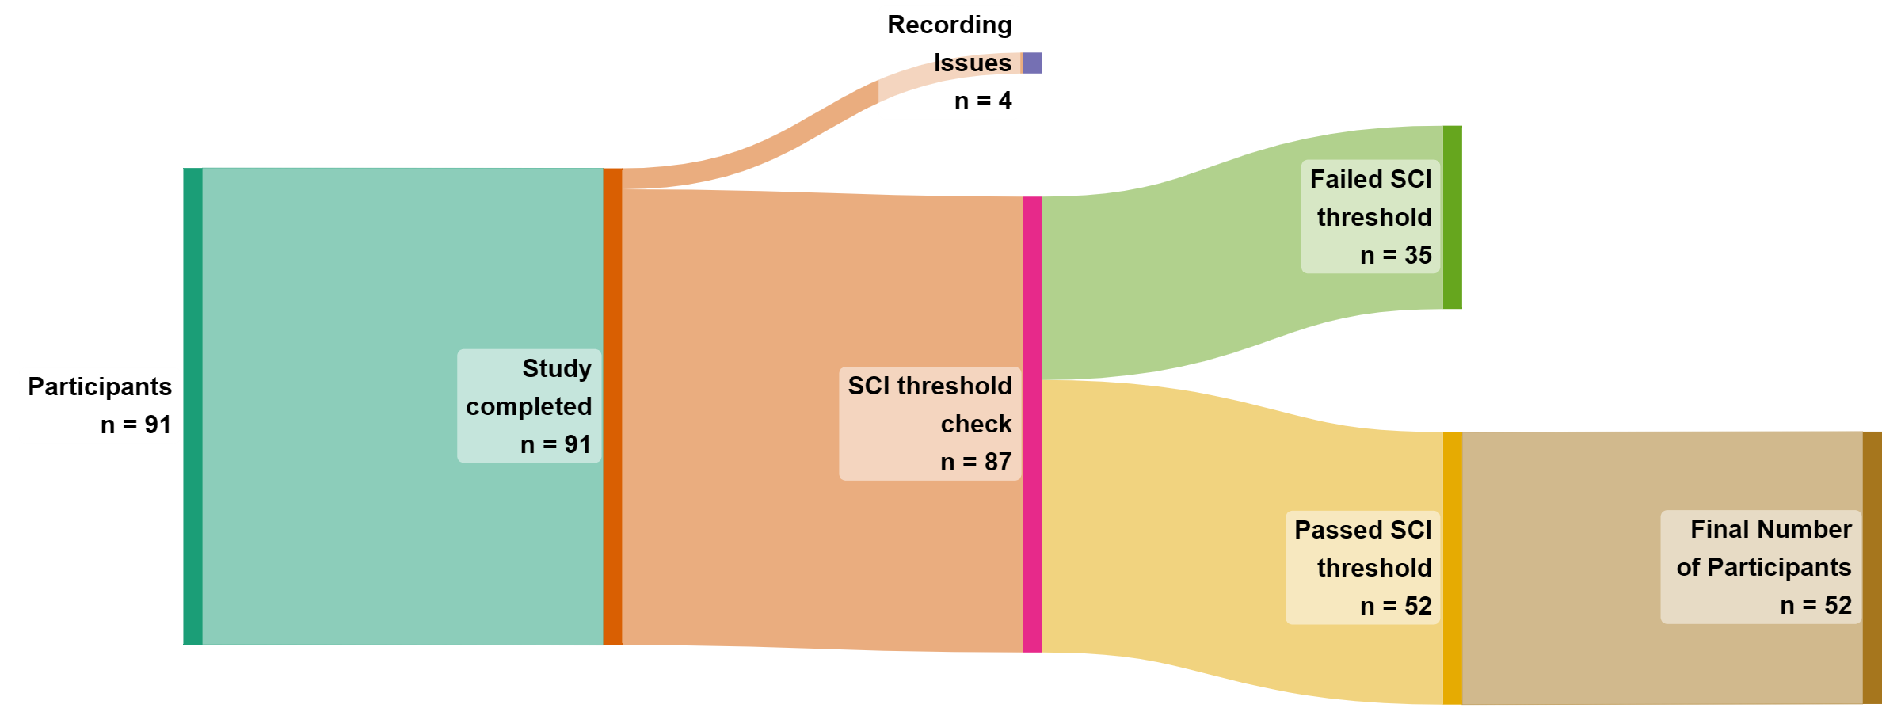and were removed prior to data analysis. The final sample consisted of 52 participants (39 females and 13 males, M = 21.62, SD = 6.67, range = 17 to 51). The study was approved by Ontario Tech’s Research Ethics Board (REB: 17656).

1. Sankey diagram showing the flow of participants through each stage of inclusion/exclusion in the study.

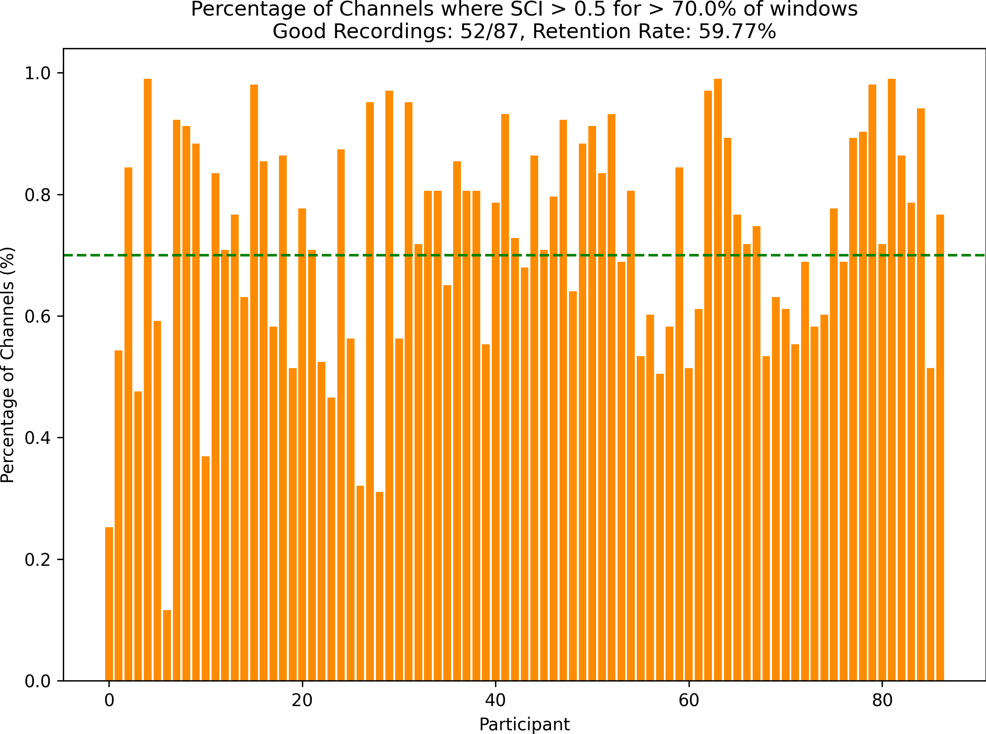

1. Percentage of Channels where SCI *>* 0.5 for *>* 70% of the windows. The green dashed line represents the threshold of 70% of windows that each participant must meet to be included in the analysis.

Figure 2.1: (A) Participant inclusion flow diagram. (B) SCI signal quality inclusion threshold.

## Stimuli and apparatus

### Stimuli

One hundred and forty images of facial expressions from the RADIATE and UIBVFED datasets were used (Conley et al., 2018; Oliver and Amengual Alcover, 2020). Then adult models (5 males and 5 females) from each dataset were identified and matched between-sets on face shape, sex, skin tone, and hair colour. Images of each model ex- pressing seven emotions (anger, disgust, fear, happiness, sadness, surprise, neutral) were selected. Expressions were selected for each model, that closely align with Ekman’s 6 basic emotions + neutral (Ekman, 1992). UIBVFED images were cropped to the same size as RADIATE images.

### Apparatus

Participants were tested individually in a quiet dedicated testing room. Stimuli were pre- sented on a Dell U2415 24-inch monitor at 1920x1200 60Hz. Participants were seated in a comfortable non-movable chair, with the monitor placed at eye level. Stimuli were pre- sented using PsychoPy3 Experiment Builder (v2024.1.5) (Peirce et al., 2019). Participant brain activity was recorded using Aurora fNIRS while participants completed the task. fNIRS data was collected using two NIRSport2 systems (NIRx Medical Technologies, Berlin, Germany). Each NIRSport2 system was equipped with 16 source and 16 detector optodes, and daisy-chained together for a high density 32x32 optode configuration. Each neighboring pair of source and detector optode is referred to as a channel, resulting in a total of 103 HbO + 103 HbR channels (plus 16 short distance channels). The average distance between source and detector optodes was 30 mm, and 7mm for short distance channels, which were placed on a flexible fNIRS head cap (NIRScap) 58 cm in circum- ference. The optodes were arranged in a high density 32x32 montage with one bundle of short distance channels, as shown in Figure 2.2. This montage was designed to cover

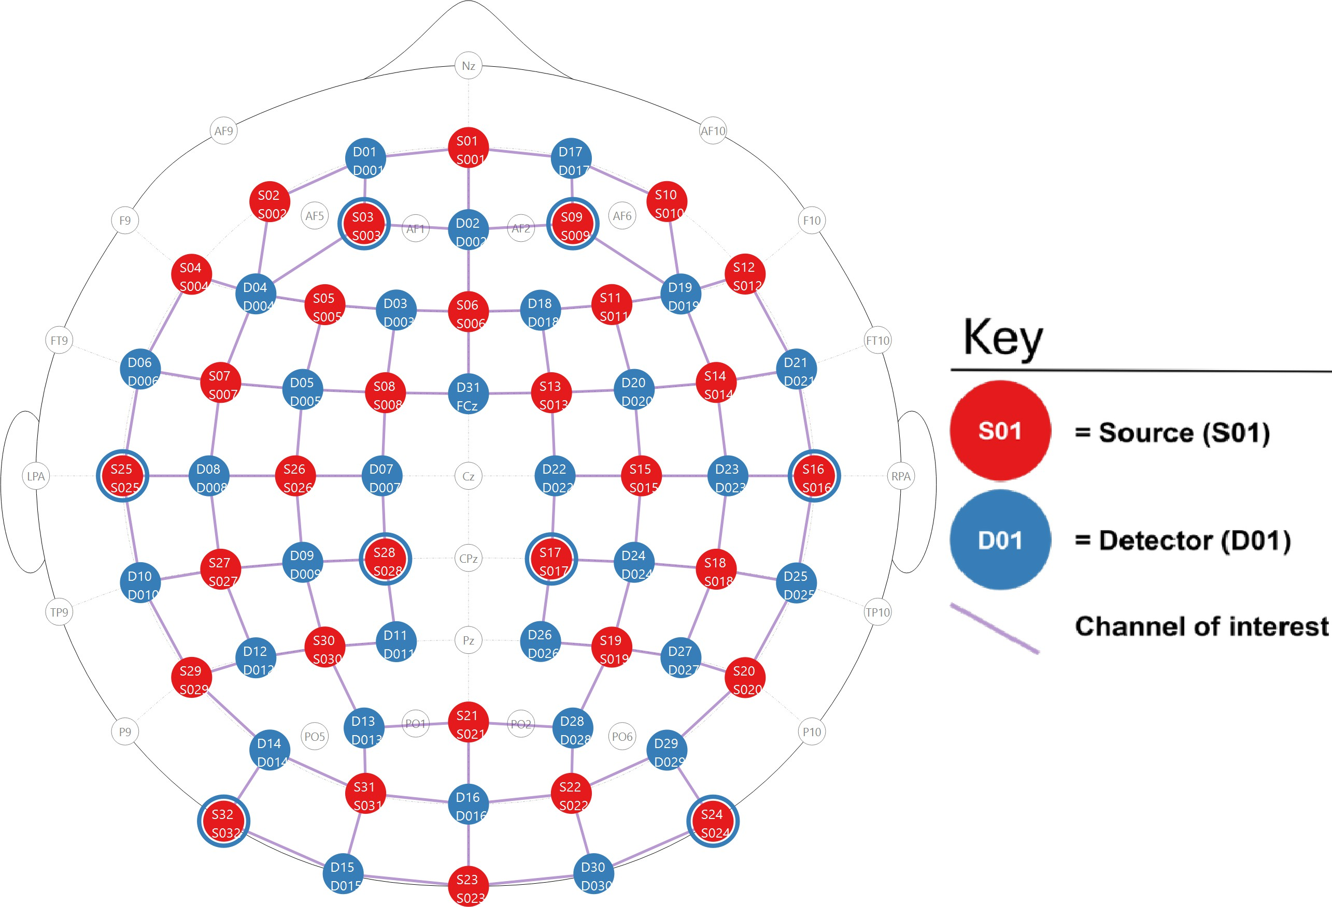a maximally large area of the brain, given increasing evidence that emotion processing is not localized to specific discrete areas of the brain, rather distributed across the brain (Lindquist et al., 2012). The fNIRS cap and optodes were positioned following the 10-20 international coordinate system. Light was emitted at 760 nm and 850 nm wavelengths, and the sampling rate was approximately 6.105 Hz.

* + - 1. 2D depiction of the montage.

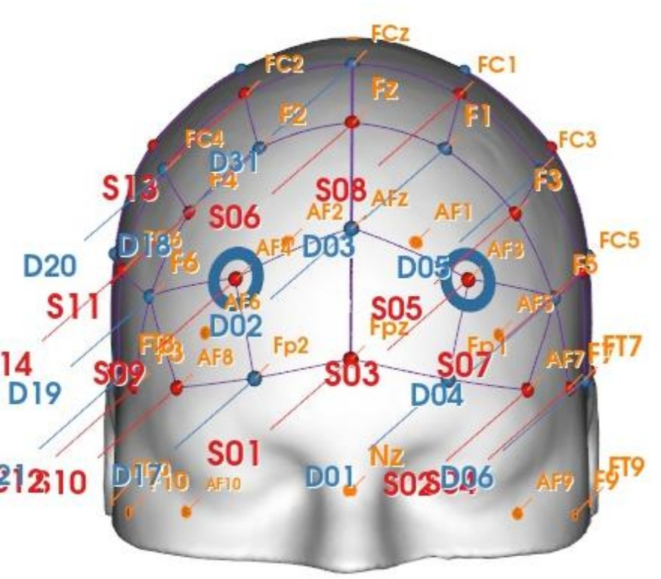 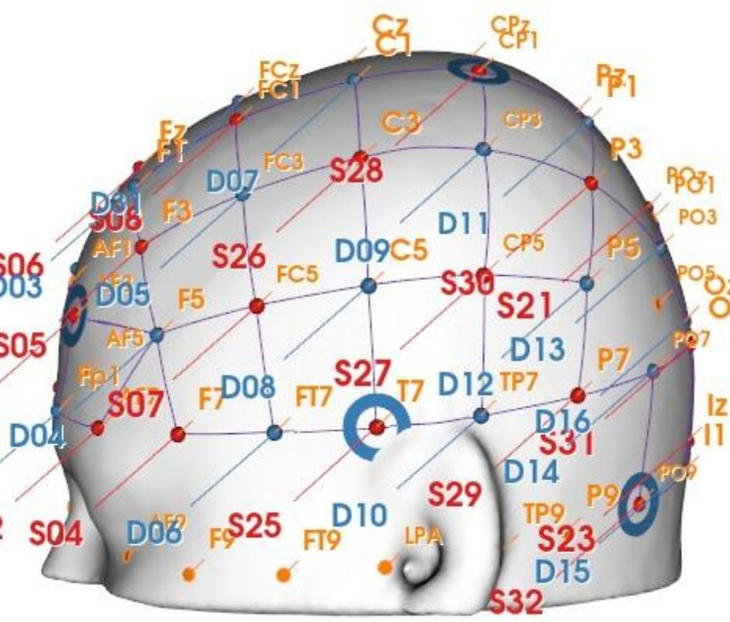

* + - 1. 3D front view of the montage. (c) 3D side view of the montage.

Figure 2.2: Depictions of the high density 32x32 optode montage. Red circles represent sources, blue circles represent detectors, purple lines represent channels, and blue rings around sources represent the locations of the 8 short distance detectors.

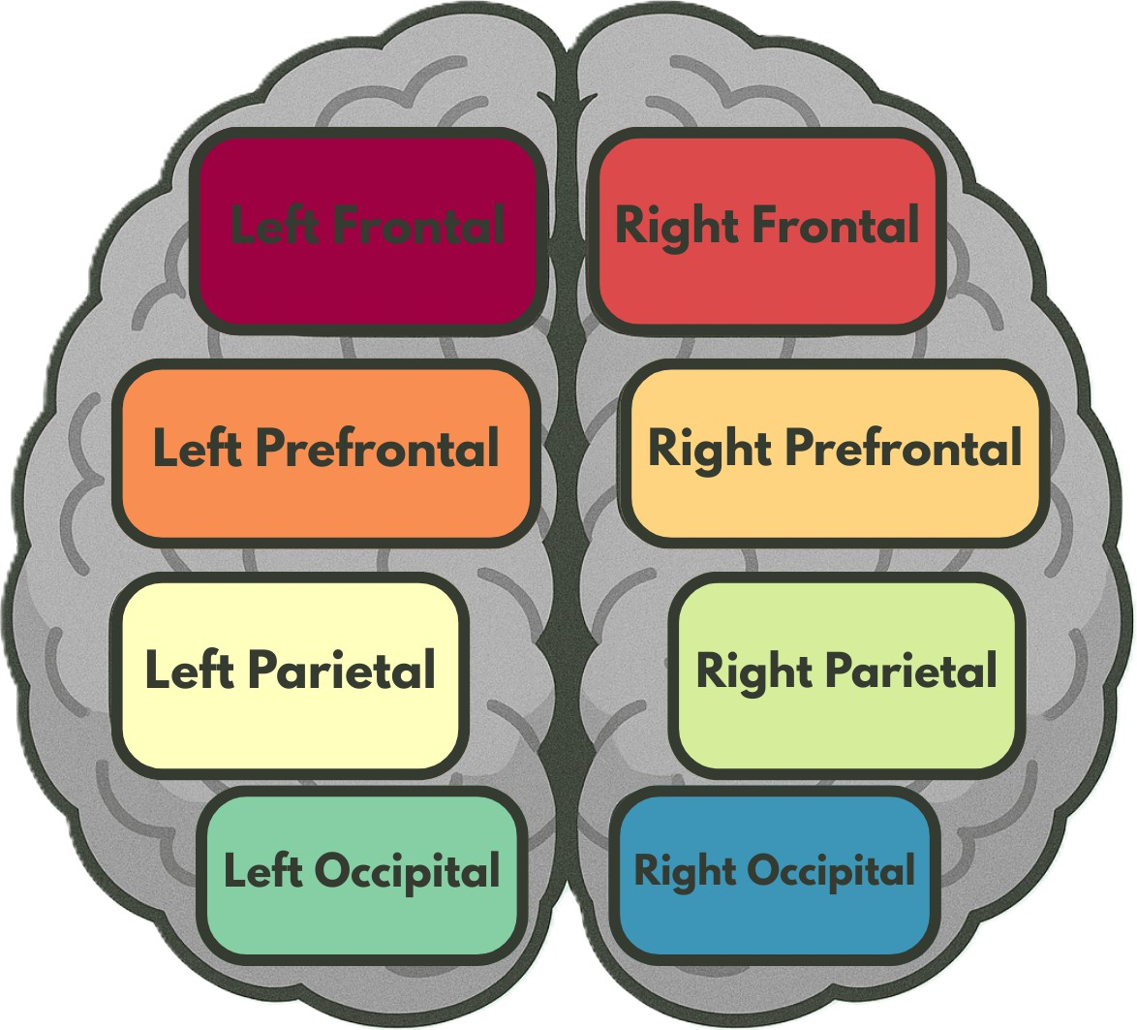

Figure 2.3: Brain region map, showing the regions of interest (ROI’s) that the channels were grouped into for certain analyses.

## Design and procedure

### Design

A full-factorial Face-type (2 levels: Real, Virtual) *×* Emotion (7 levels: Anger, Disgust, Fear, Joy, Sadness, Surprise, Neutral) *×* Model (4) *×* Sex (2 levels: Male, Female) *×* Repetition (4) experimental design was used, with each participant presented with 448 images. Stimuli were blocked and counterbalanced by Face-type and Emotion. Within each of the 56 Face-type-Emotion Blocks, participants were presented with 8 distinct model faces (4 male, 4 female).

### Procedure

Following consent and briefing, participant head size was measured and a size-appropriate fNIRS cap fitted. A signal optimization routine was then run within Aurora fNIRS to optimize participant channel signal levels. This routine worked by increasing source brightness in a stepwise manner, until the optimal signal levels for all channels was reached. Following optimization, participants were told that they would be presented with a series of facial expression images and asked to identify whether a probe face matched one of the faces they saw in the preceding block. Room lights were then switched off to avoid interference with the fNIRS cap, and participants were monitored from an adjacent room with a live camera feed.

The experiment began with instructions presented on screen. The trial timeline, shown in Figure 2.4, consisted of three main epochs: fixation cross, block presentation, and participant feedback. Each Block began with a fixed cross presented for 16 seconds, followed by 8 facial images. Facial images were each presented for 1.5 seconds, with a 250-750 ms (M=500 ms) interstimulus interval (ISI) between each face. To maintain participant attention, participants completed a memory task after each block. In the task, participants were presented with a model image with the same emotional expression as the rest of the block’s images, and asked if the model was shown in the preceding block of 8 faces, with feedback provided using the keyboard (y/n). The probe face has a 50% chance of either being in the previous block or not. The experiment continued after seven seconds if no feedback was provided. Most participants only failed to respond to 1-2 blocks of the 56 blocks, with only a handful of participants failing to respond to up to 5 blocks, as illustrated in Figure C.1. Participants were given a break every seven blocks, and prompted to enter the space bar when they are ready to continue the experiment. After the experiment was completed, the experimenter(s) entered the room, removed the fNIRS cap, and the participant was debriefed about the experiment. Participation in the experiment took approximately 35 minutes.

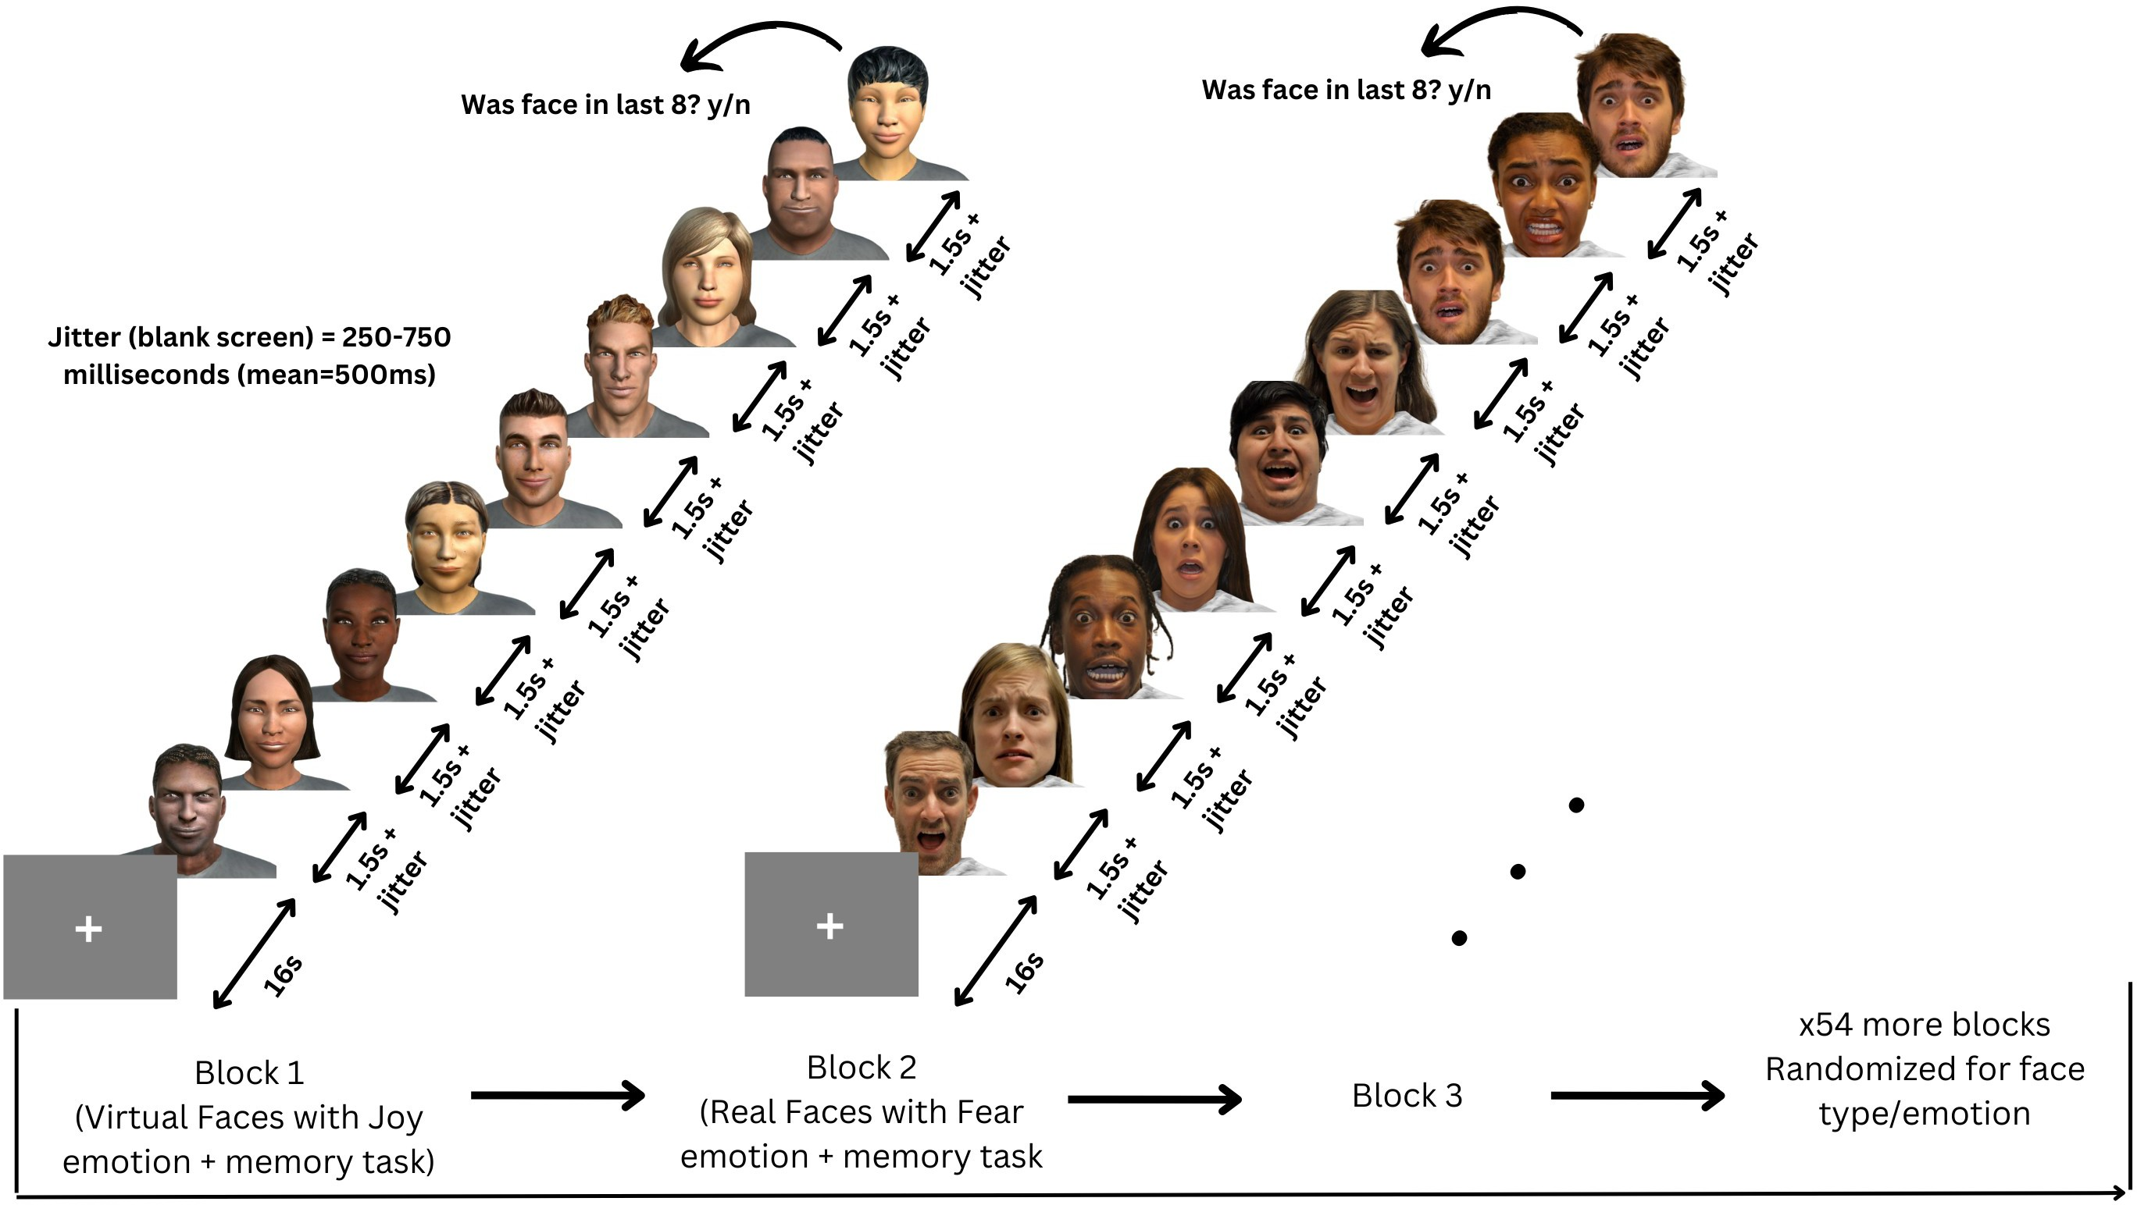

Figure 2.4: Participants viewed 56 blocks of 8 faces, each block being either all real or all virtual faces. Every face in a block displayed the same emotional expression, one of: anger, disgust, fear, happiness, sadness, surprise, neutral.

## Analyses

All fNIRS data was preprocessed and analyzed with Python 3.11.9 using MNE (version 1.9.0) (Gramfort et al., 2013) and MNE-NIRS (version 0.7.1) (Luke et al., 2021), which used the Nilearn package (version 0.9.2). Data were analyzed with a General Linear Model (GLM), followed by a functional connectivity analysis. The memory task was analyzed in Python using the statsmodels package (version 0.14.4) (Seabold and Perktold, 2010).

### fNIRS preprocessing

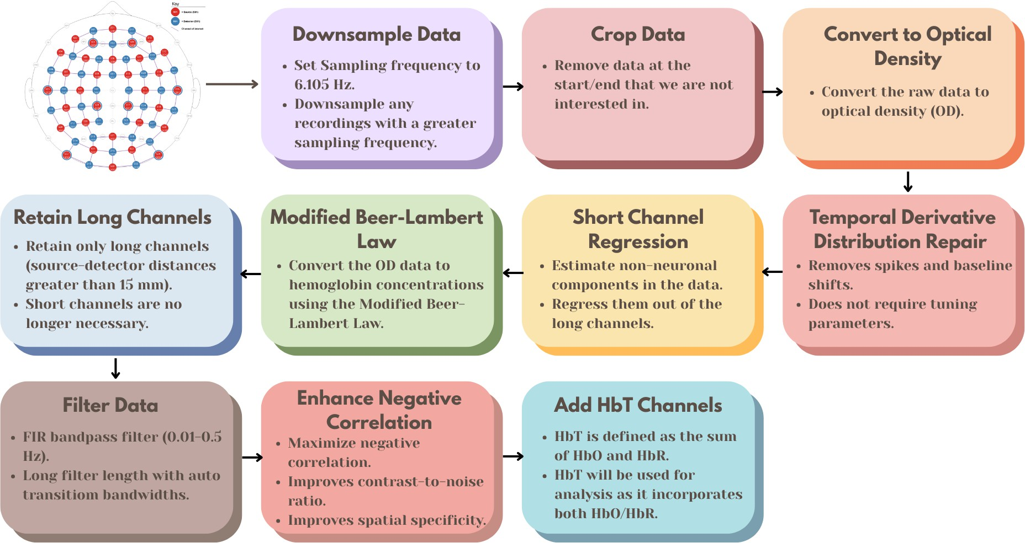

Figure 2.5: Preprocessing steps for fNIRS data, from the raw data to the fully processed data.

The preprocessing steps for the fNIRS data, as shown in Figure 2.5, were as follows:

1) Downsample the data if the sampling frequency is greater than 6.105 Hz, the initial two datasets were sampled higher than 6.105 Hz, and the sampling frequency should be consistent across all datasets. 2) Crop the data to the first and last annotation. This gets rid of the extra data at the beginning and end of the recording that are not of interest. 3) Convert the raw data to optical density. 4) Apply temporal derivative distribution repair to the OD data (Fishburn et al., 2019). TDDR is effective at removing spikes and baseline shifts from the data. 5) Apply short channel regression to the OD data (Scholkmann et al., 2014). Short channels are used to estimate the superficial hemodynamics (non- evoked/extracerebral/systemic components) in the data, and then regress it out of the long channels (Tachtsidis and Scholkmann, 2016). 6) Convert the OD data to hemoglobin concentrations using the modified Beer-Lambert law. The MBLL relates the change in light attenuation to the change in hemoglobin concentration of chromophores in the

tissue (Kocsis et al., 2006). 7) Retain only long channels (source-detector distance *>* 15 mm). Since the short channels have already been regressed out, it is no longer necessary to keep them in the data. 8) This FIR bandpass filter extracts signal components in the 0.01-0.5 Hz range, it uses a long filter length (2015 samples) with automatically determined transition bandwidths by MNE-Python (Pinti et al., 2019). 9) Maximizes negative correlation between HbO and HbR (Cui et al., 2010). This method removes spikes, improves contrast-to-noise ratio, and improves spatial specificity of the data. 10) Add HbT (hemoglobin total) channels to the data. HbT is defined as the sum of HbO and HbR. Often, fNIRS studies will only use either one of HbO or HbR channels (more frequently HbO), leaving out one channel with no justification (Kinder et al., 2022). Therefore, HbT channels are chosen, as HbT makes use of both HbO and HbR channels, and using both hemoglobin species improves the inferences as to where activation occurs Hocke et al. (2018).

Variable length epochs were created for each block of 8 faces, which were 14-18 seconds long (mean = 16s), depending on the ISI’s (see 2.3.2). Epochs were sorted by Face Type (Real, Virtual), and Emotion (Anger, Disgust, Fear, Happiness, Sadness, Surprise, Neutral), and their interaction. Baseline correction was applied to remove any constant or slowly varying offsets in the data. The data was annotated with the onsets and offsets of each block, along with the duration and condition of each block. Block data were then analysed using a GLM and Functional Connectivity analysis.

### Activation magnitude with General Linear Model (GLM)

The General Linear Model (GLM) posits that the observed haemodynamic signal at each channel or Region of Interest (ROI) is a linear combination of task-related regressors convolved with a Hemodynamic Response Function (HRF), plus nuisance regressors (e.g., drift) and residual noise. Mathematically,

*Y* = *Xβ* + *ϵ,* (2.1)

where *Y* is the observed time series, *X* is the design matrix, *β* represents the parame- ters to estimate, and *ϵ* denotes the residuals assumed to be Gaussian noise. Estimation is performed via ordinary least squares (OLS), yielding parameter estimates that quantify condition-specific activation amplitudes.

#### Design Matrix

For each of the epochs, events are defined by their trial type (e.g., emotion or face type), and onsets/offsets relative to the procedure start, and duration. The design matrix is constructed using Nilearn’s make first level design matrix by convolving a boxcar function (based on the event timing) with a canonical HRF, which is a model of the expected haemodynamic response to neural activity. The canonical HRF Statistical Parametric Mapping (SPM) (Friston, 2007) is chosen to model neurovascular coupling, this model captures the stereotypical rise and fall of the BOLD/fNIRS response. The cosine drift model was utilized, which incorporates discrete cosine transform (DCT) basis functions into the design matrix to model and remove low-frequency drifts. The selection of the high pass cutoff frequency is guided by the structure of the experimental design. The cutoff period is set to twice the duration of the longest inter-trial interval, and each fixation period between epochs (or blocks) is 16 seconds. Therefore, a cutoff period of 32 seconds (i.e., high pass=0.03125 Hz) would be appropriate. This ensures that the drift model does not remove task-related signal components that occur at frequencies higher than the cutoff (Luke et al., 2021). The design matrix *X* and preprocessed time series are fed into MNE’s run glm function, which computes OLS estimates of *β* for each channel.

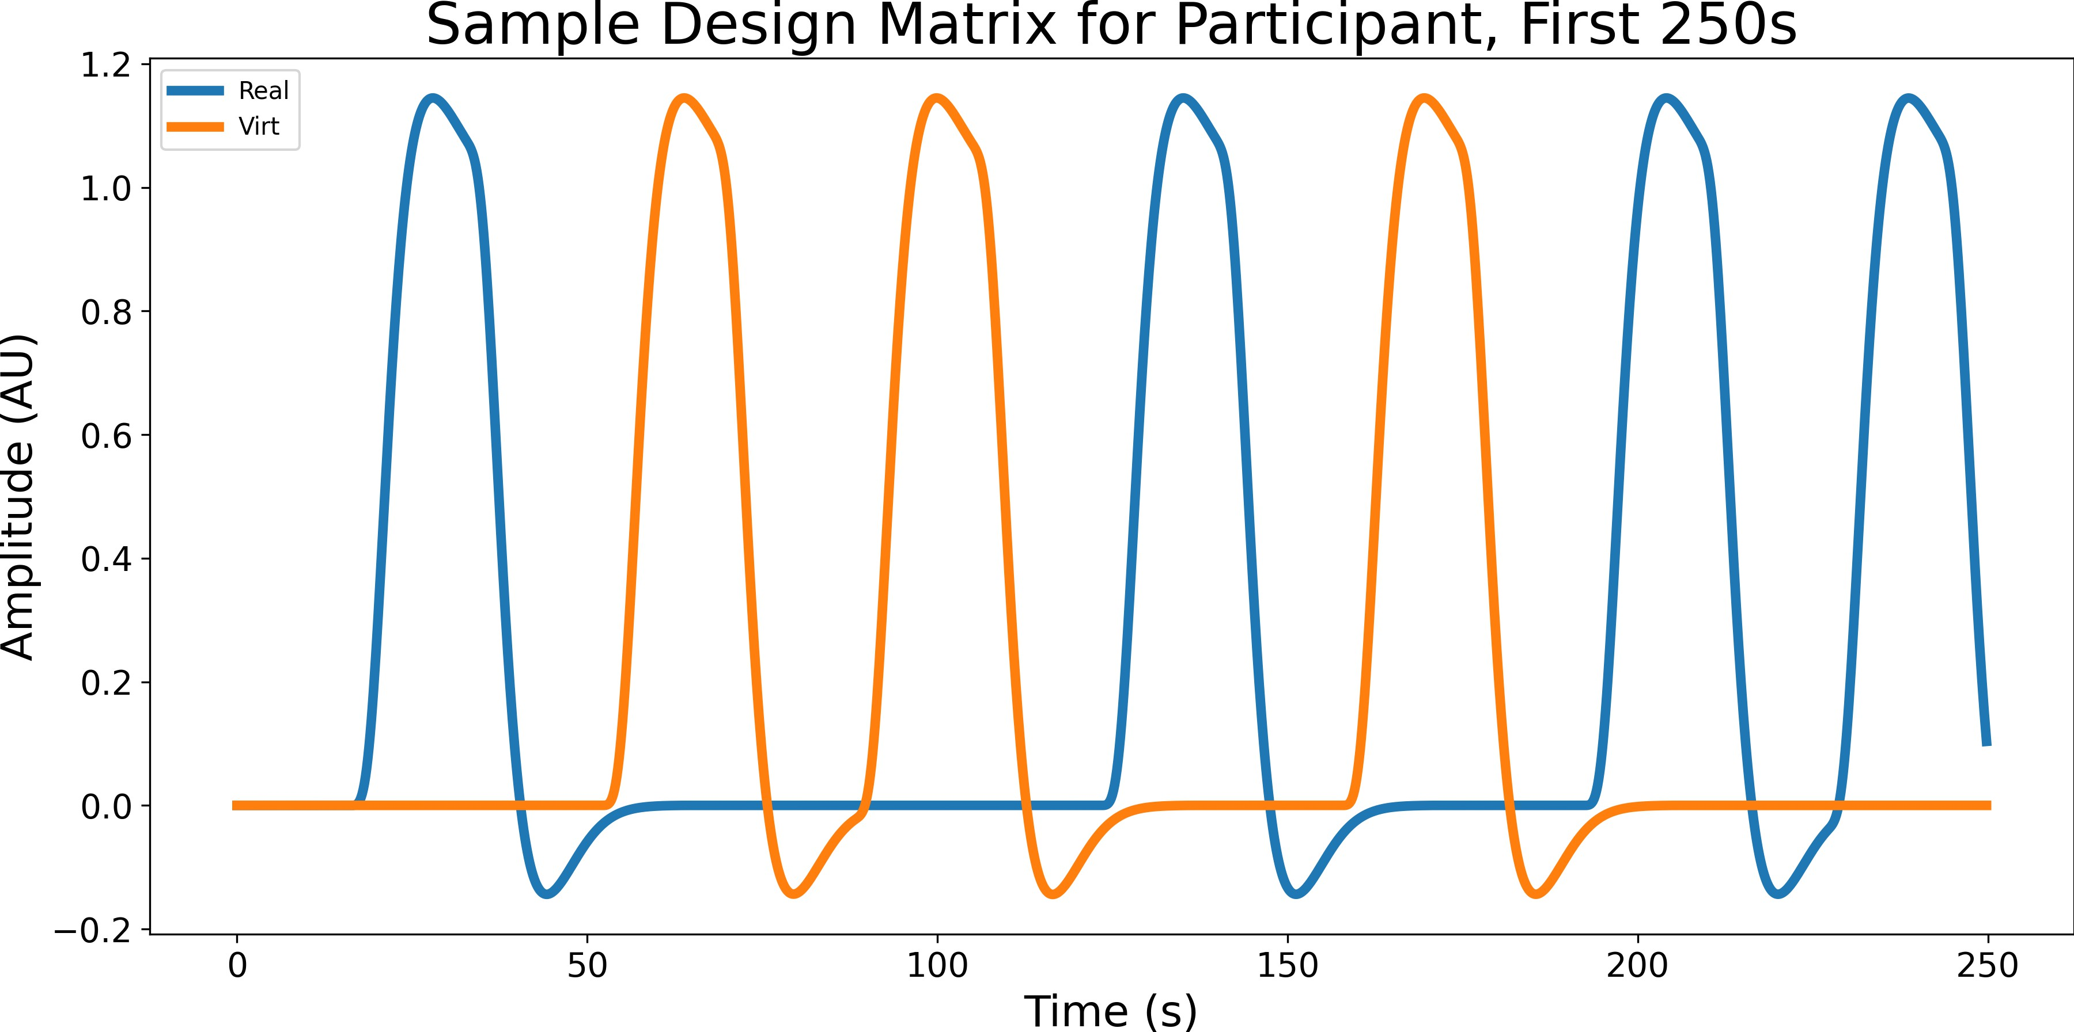

Figure 2.6: Sample design matrix for a single participant for the effect Face type, showing the first 7 blocks (250 seconds) of a single experiment. The design matrix is organized by condition (Blue for real, orange for virtual), this is the result of convolving the boxcar function with the canonical HRF SPM.

A two-way repeated measures GLM was conducted on participant’s HbT responses by Face-type (2 levels: Real, Virtual) and Emotion (7 levels: Anger, Disgust, Fear, Joy, Sadness, Surprise, Neutral). Pairwise contrasts were then computed between conditions to identify effects of interest.

#### Contrast Computation

All pairwise contrasts were generated between conditions by constructing an identity con- trast matrix over design columns. For each pair of conditions (*A, B*), the contrast vector is defined as: *c* = *eA − eB*, where *eA* and *eB* are the respective design matrix columns for conditions *A* and *B*. Contrasts are computed using MNE’s compute contrast function, which produces effect estimates and test statistics aggregated across channels. Since numerous statistical tests are performed across channels and contrasts, *p*-values were corrected for false discovery rate (FDR) using the Benjamini-Hochberg procedure (Singh and Dan, 2006) with a family-wise error rate of *α*=0.05.

### Network mapping with Functional Connectivity Analysis

To characterize the temporal coordination between fNIRS channels during face and emotion processing, functional connectivity matrices were computed using a continuous wavelet transform (CWT)-based spectral connectivity approach. CWT decomposes sig- nals into simultaneous time-frequency representations, providing an optimal framework for fNIRS connectivity analysis by accommodating the non-stationary, physiological na- ture of hemodynamic signals. The morlet wavelet, a gaussian function modulated by a sine wave, was picked as they are suited to capture both slow neural rhythms and faster systemic fluctuations in fNIRS data (Reddy et al., 2021). Wavelet-based approaches have been widely adopted in the fNIRS literature for connectivity and even artifact correction (Bergmann et al., 2023; Hakim et al., 2023) Coherence combines both phase and ampli- tude information into a single, normalized index, 0 (no coupling) to 1 (perfect coupling), and is a richer description of coupling than phase-only or amplitude-only metrics (Bastos and Schoffelen, 2016).

For each participant, MNE’s spectral connectivity time function was applied to compute time-resolved coherence across pairs of channels, the average of this was taken across epochs to obtain a single channel-by-channel connectivity matrix for each condi- tion. Each participants’ connectivity matrix was then averaged across participants to obtain a group-level connectivity matrix for each condition. fNIRS hemodynamics pre- dominantly fluctuate in very low frequencies (0.01-0.5 Hz) (Reddy et al., 2021). The frequency range was narrowed to five evenly spaced frequences between 0.2-0.5 Hz due to short epoch length, this range still targets systemic and neurogenic oscillations while avoiding high-frequency noise (Xu et al., 2017). Averaging across these closely spaced fre- quencies reduces data dimensionality, simplifying downstream statistical analyses without sacrificing sensitivity to coupling dynamics.

#### Paired Sample t-tests

For each mode (Face type/Emotion), and pair of conditions (e.g., Joy vs. Fear), individual- level connectivity matrices were extracted, averaging across epochs and time points to obtain, per participant, a symmetric channel-by-channel coherence matrix. Because co- herence values are bounded between 0 and 1 and exhibit skewed distributions (Miranda de S´a et al., 2009), Fisher’s r-to-z transform (atanh) was applied to each matrix element to normalize the data prior to parametric testing. Paired t-tests for each unique channel pair (*i > j*) were then conducted across participants using SciPy’s ttest rel. This di- rectly tests whether mean connectivity differs between conditions, leveraging the paired design to increase statistical sensitivity (Hu et al., 2023). Given the large number of channel-pair tests, and similar to the GLM analysis above in 2.4.2, *p*-values were cor- rected for FDR using the Benjamini-Hochberg procedure (Singh and Dan, 2006) with a family-wise error rate of *α*=0.05.

#### ROI Chord Plots

To distill high-dimensional channel-by-channel connectivity into interpretable inter-regional summaries, we mapped individual fNIRS channels onto anatomically defined ROI’s. This includes left and right frontal, prefrontal, parietal, occipital regions of the brain as shown in Figure 2.3, and the channels were grouped into these regions based on their location in the montage. Since multiple channels may map to the same pair of regions (e.g., several left prefrontal channels connecting to several right occipital channels), we aggregated all significant connections (*p <* 0.05) between two regions by taking the mean of their

t-values.

### Memory Task Analysis

Raw behavioral data captured from PsychoPy were preprocessed to identify participant keyboard responses. The total correct trials per participant were summed. Since each

block of faces was either all real or all virtual, and all had the same emotional expression (as discussed in 2.3.2), each y/n response was labeled with Face type and Emotion. An OLS model was fit with accuracy (converted to numeric 0/1) as the dependent variable and categorical predictors for Face Type, Emotion, and their interaction. The goal is to determine the main effects of these two factors individually, as well as their interaction, on response accuracy. A two-way Type III ANOVA (via sm.stats.anova lm(model, typ=3)) provided *F* -statistics and *p*-values for main effects and interaction. This version of the ANOVA is especially suitable when interactions are included in the model, as it calculates each effect after accounting for all other terms.

# Chapter 3 Results

## Activation magnitude

#### Neural Responses to real and virtual faces

A main effect of Face type was reported, with pairwise contrasts revealing greater activation for virtual faces compared to real faces, as shown in Figure 3.1.

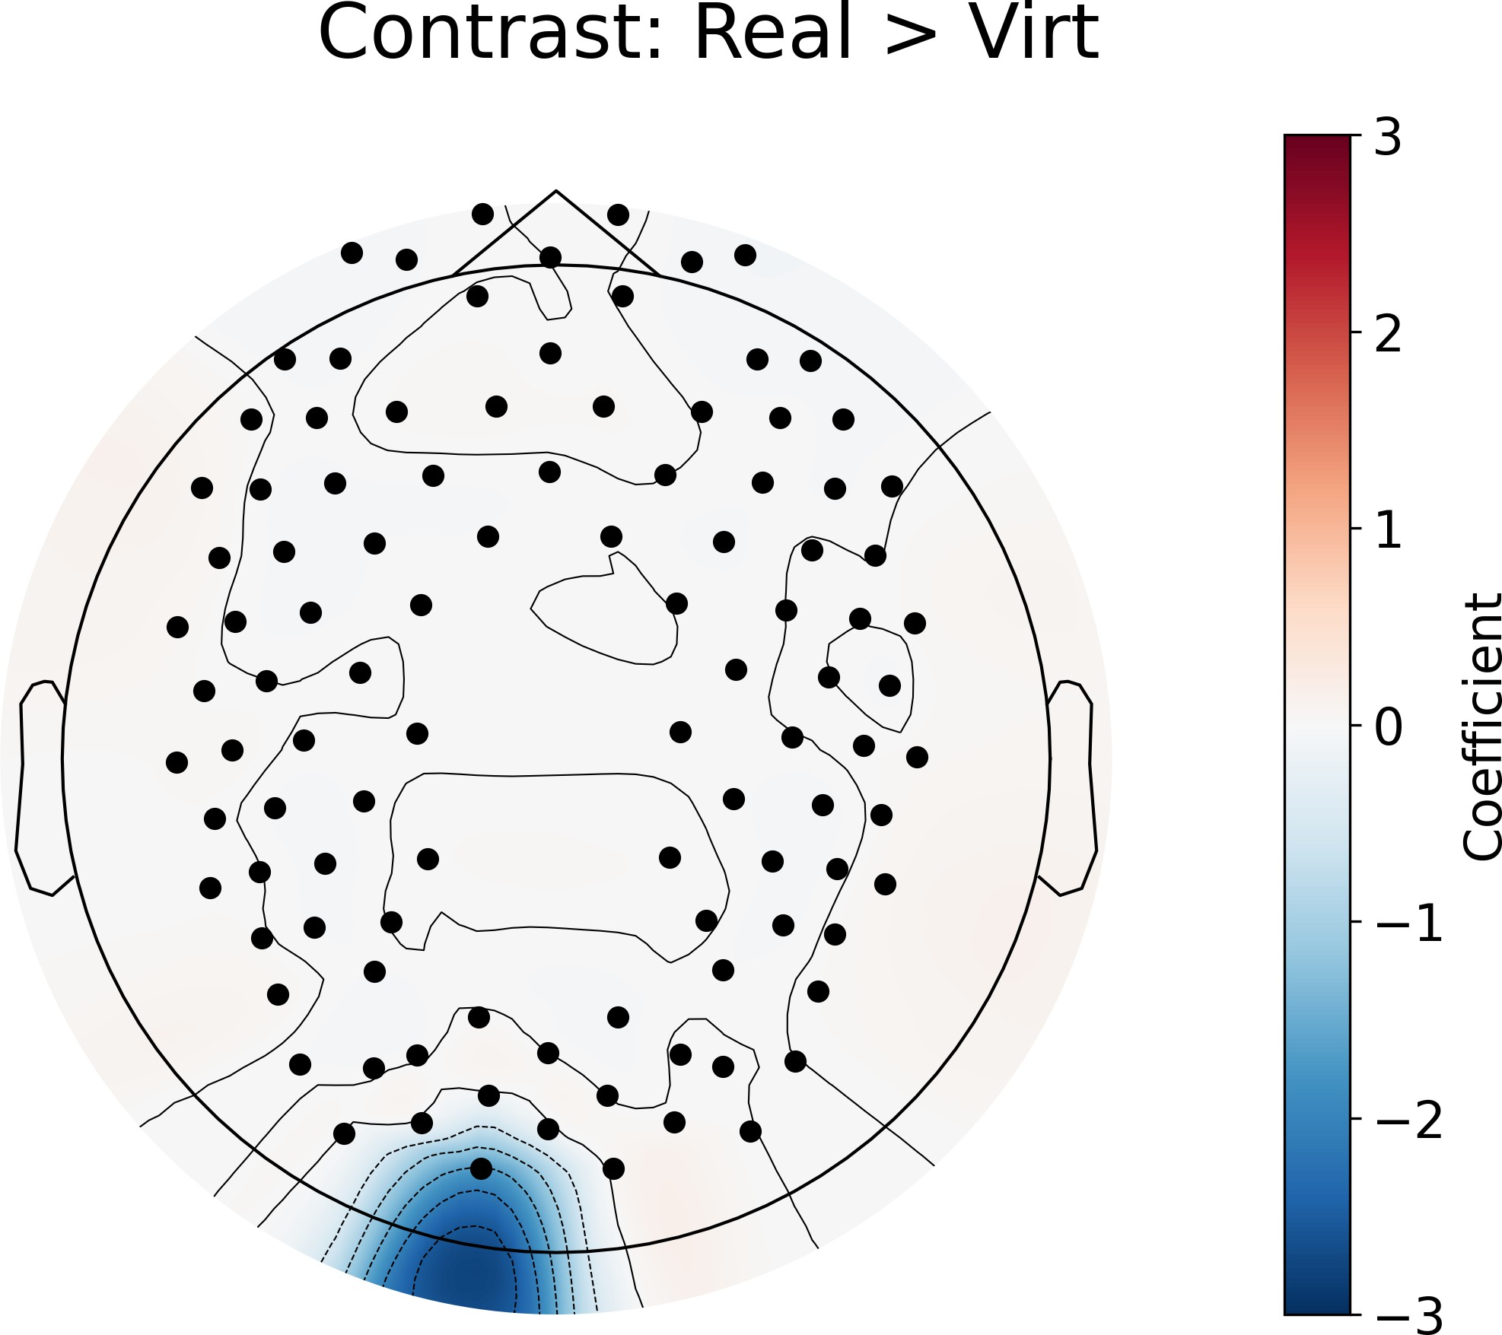

Figure 3.1: GLM contrast between real and virtual conditions which shows the differences in activation between the two conditions. Red signifies that condition 1 (real faces) has more activation in that area than condition 2 (virtual faces), while blue signifies that condition 2 (virtual faces) has more activation than condition 1 (real faces). The color bar on the right shows the coefficient of the contrast, which indicates the strength of the difference in activation between the two conditions.

16

#### Neural Responses to different emotions

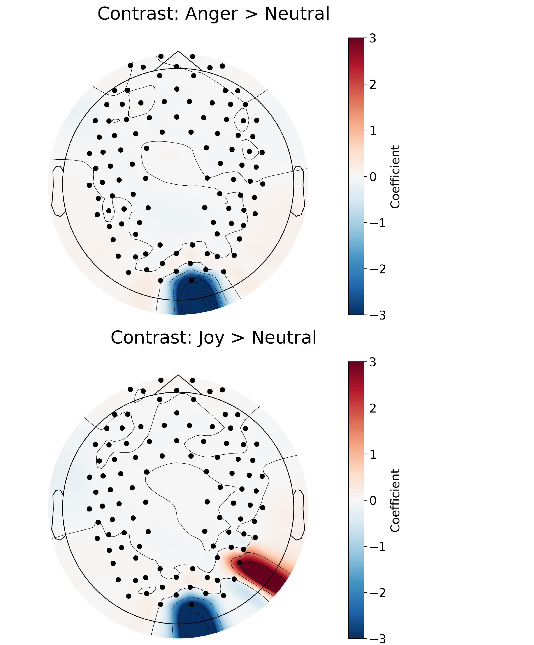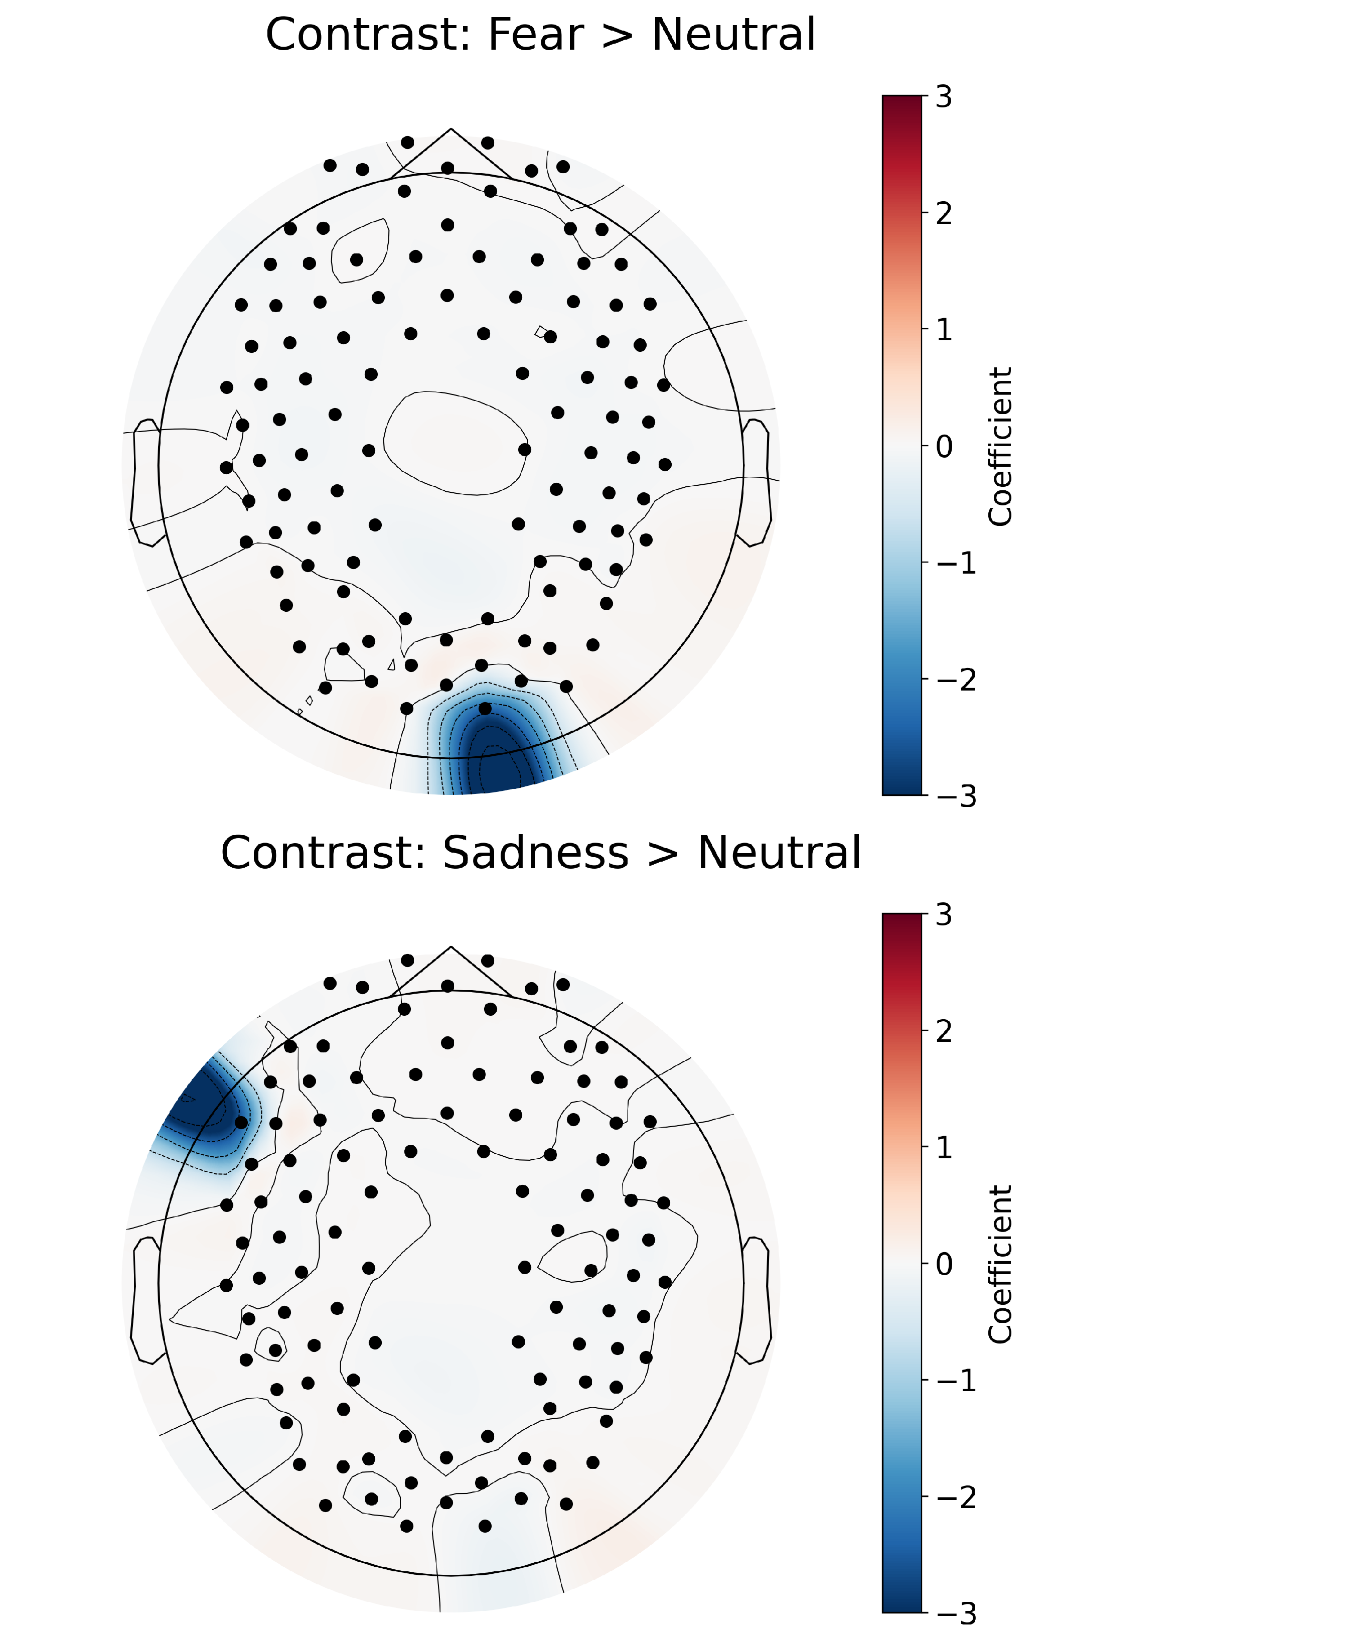Pairwise contrasts with Neutral (control) and other emotions revealed significant dif- ferences in activation across several brain regions (Figure 3.2). For instance, perceiving Anger, Fear, and Joy elicited less activity in the right occipital region than perceiving Neutral. Morever, processing Joy was associated with less activity in the right parietal region, while processing Sadness produced less activity in the left frontal region relative to processing Neutral. These results indicate distinct neural activation patterns for each emotion when contrasted against the ”baseline” Neutral condition, with most prominent differences in neural activity over the occipital region.

Figure 3.2: GLM results for the contrast between different emotions and neutral condi- tion.

Interestingly, processing Surprise was most consistently different from processing other emotions (Figure 3.3). We found processing Surprise produced 1) more activity in the left prefrontal and right occipital regions relative to processing Disgust and Joy,

2) more activity in the right parietal region relative to processing Fear, 3) more activity

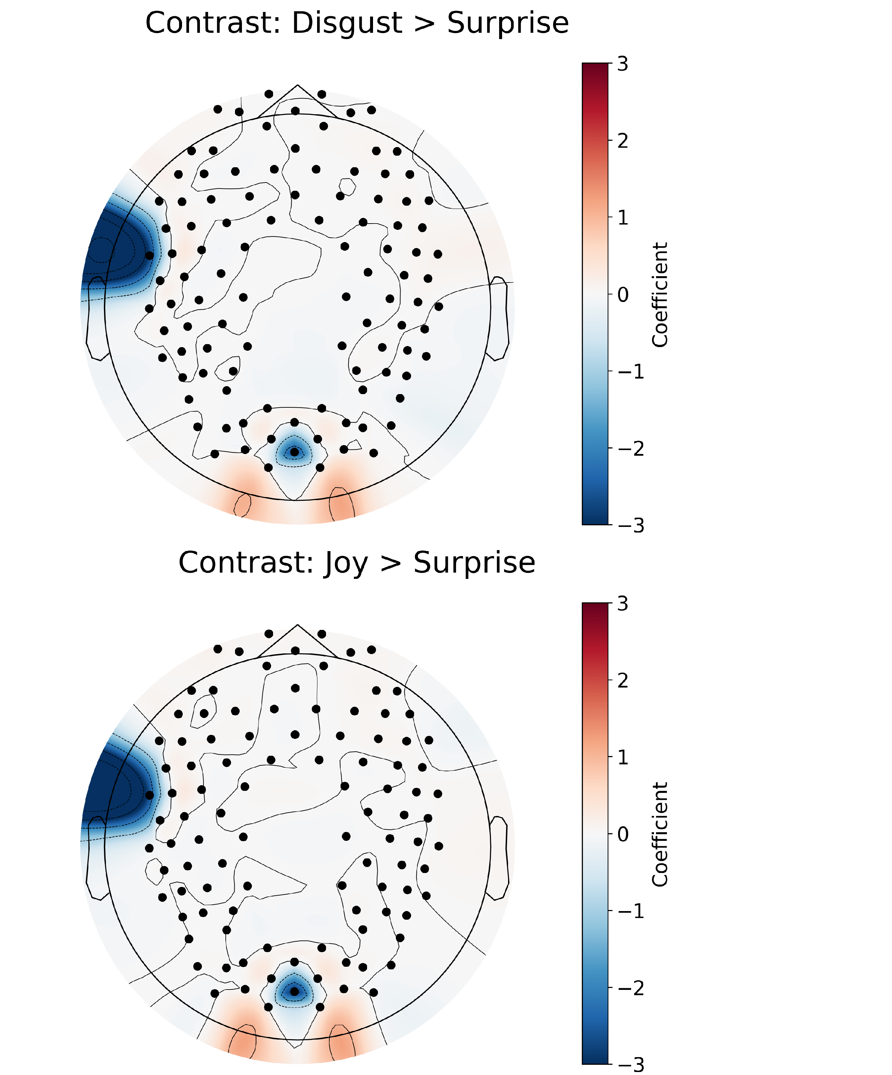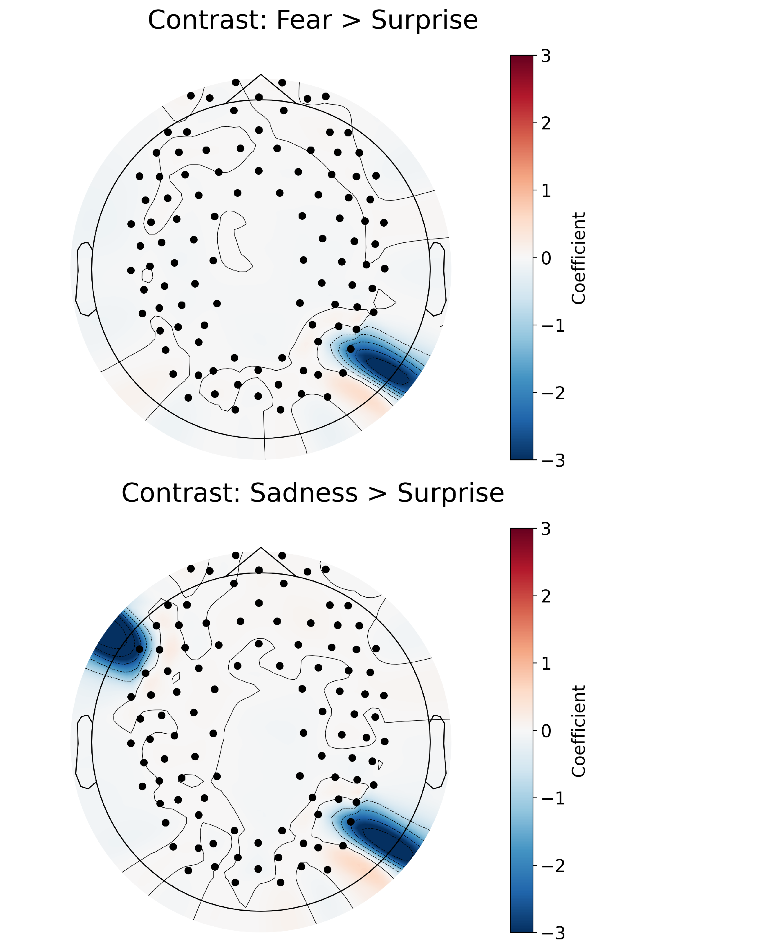in the left frontal and right parietal regions relative to processing Sadnessl, and 4) more activity in the right parietal region and less activity in the right occipital region relative to processing Neutral. These findings suggest that Surprise is distinct from processing Neutral but also other emotions, with differences in neural activity more widespread that include prefrontal and parietal regions. All combinations of emotion contrasts were performed, significant differences were only found between Neutral relative to the other emotions, and between Surprise relative to the other emotions.

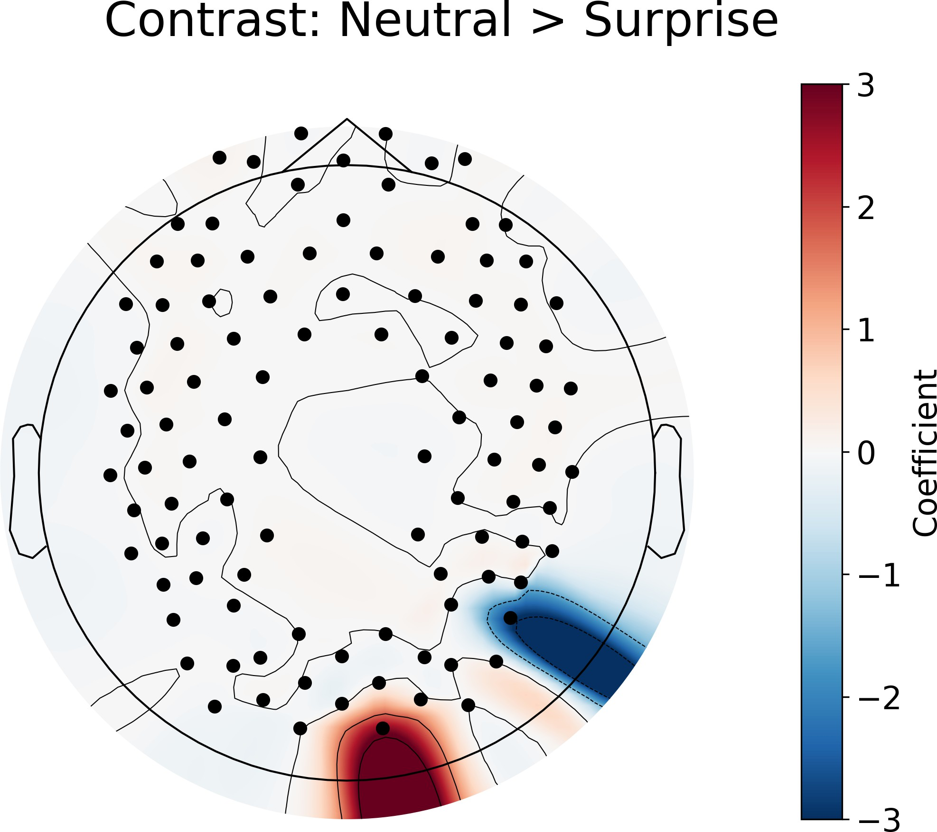

Figure 3.3: GLM results for the contrast between different emotions and surprise condi- tion.

#### Differential neural responses to emotions and face type

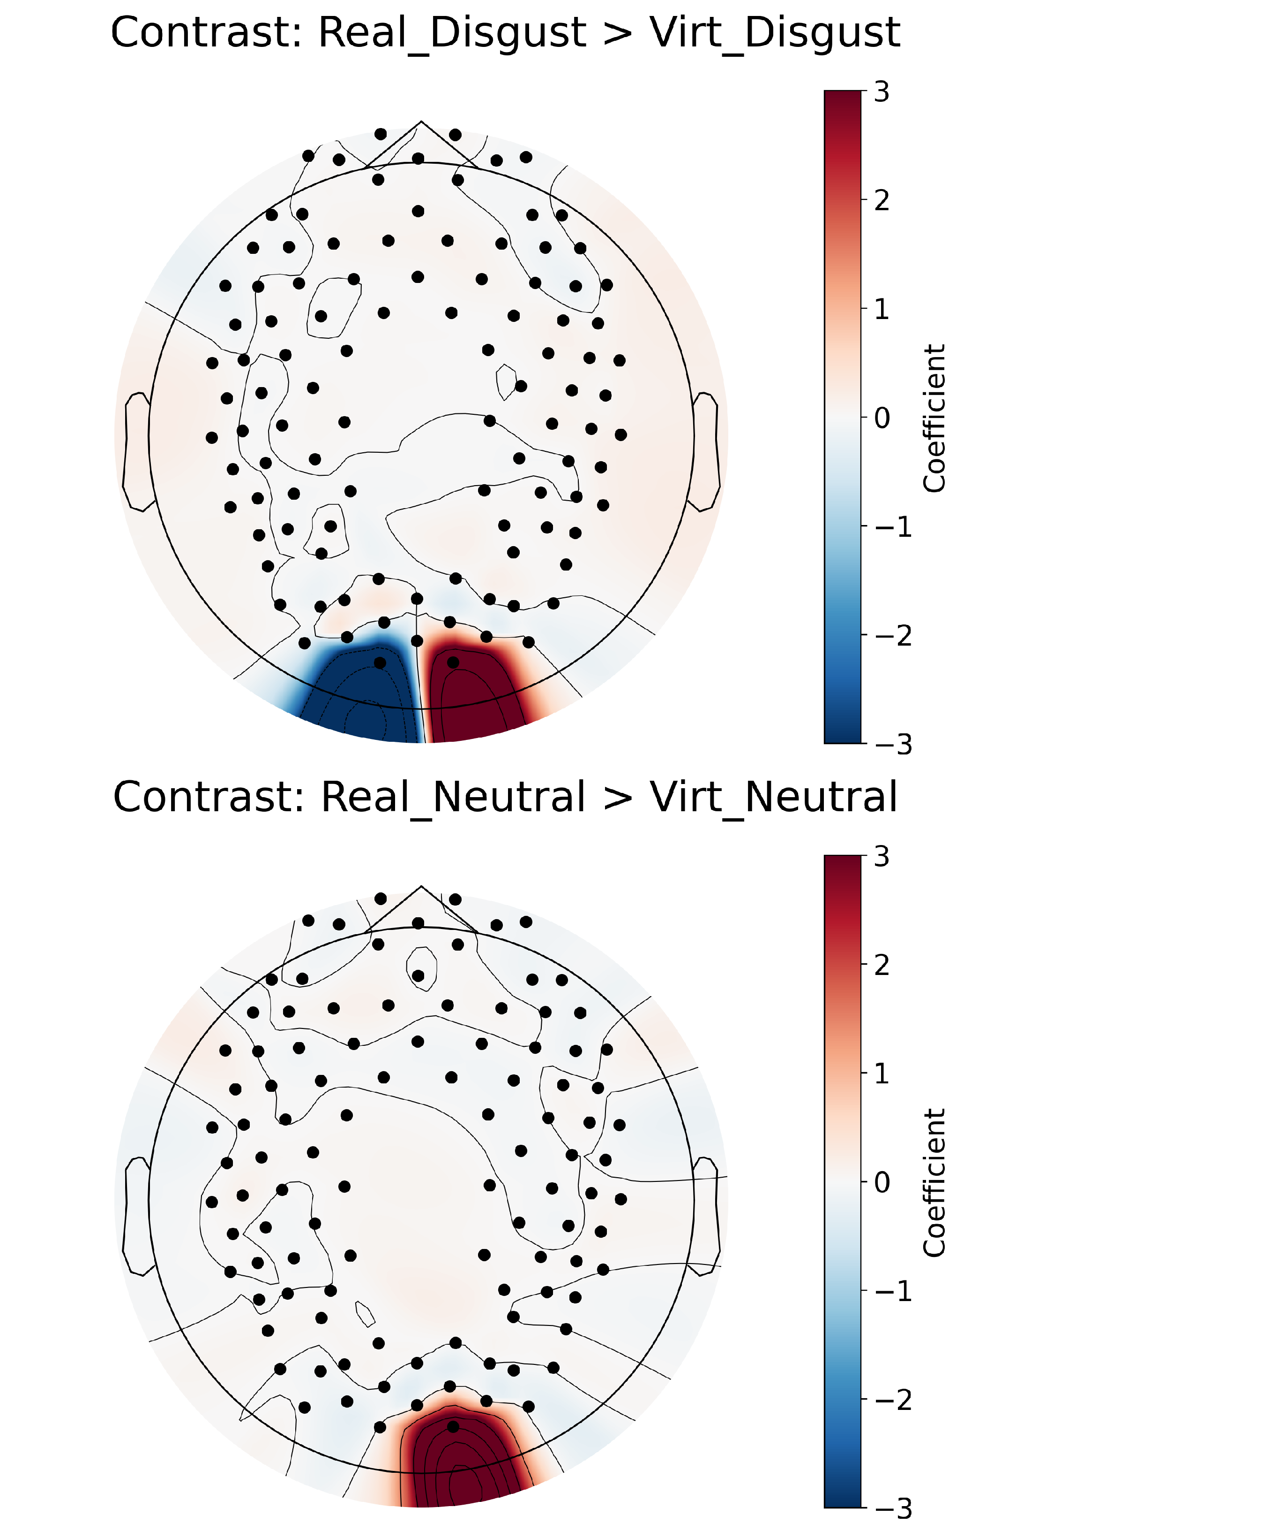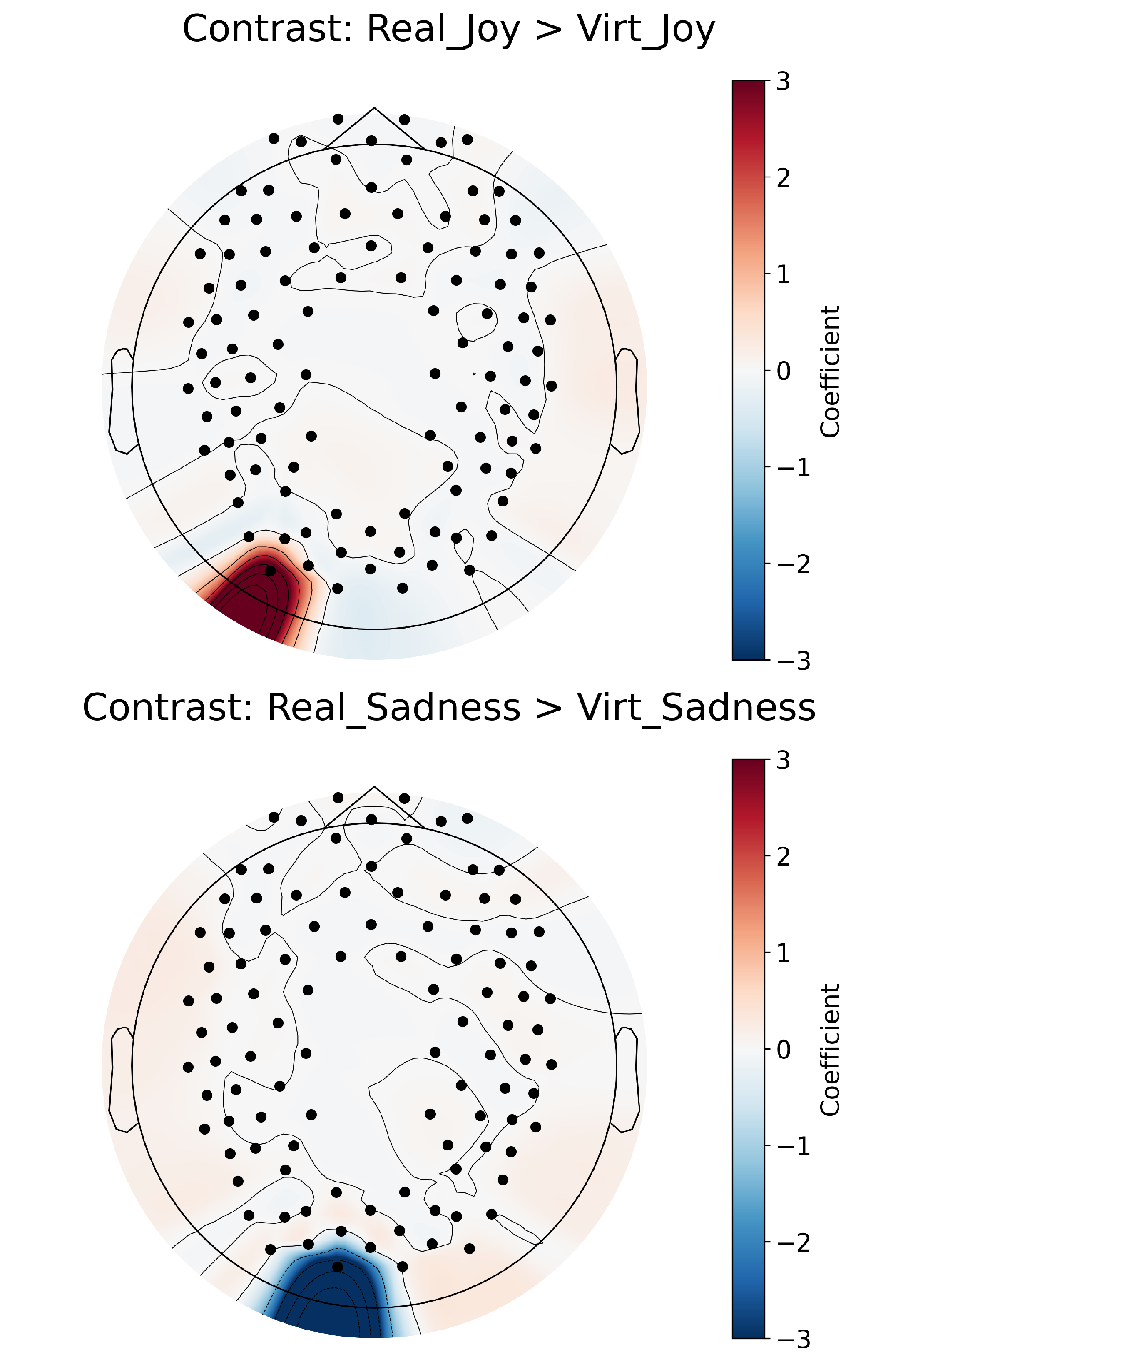The interaction of Real *>* Virtual within each emotion, as shown in Figure 3.4 revealed significant differences in occipital regions exclusively. Specifically, processing Disgust on real faces elicited greater activity in the right occipital region compared to processing Disgust on virtual faces, whereas the left occipital region showed the opposite pattern. Moreover, processing Joy and Neutral emotions on real faces also elicited greater activity in the occipital regions compared to processing the same emotions on virtual faces. We found processing Sadness on virtual faces produced more activity in the left occipital region for virtual faces compared to processing Sadness on real faces. These findings suggest that the neural response to emotional expressions is modulated by the realism of the face stimuli. The full table of the GLM contrasts for all main effects and interactions can be found in Appendix A.

Figure 3.4: GLM results for the contrast between real and virtual conditions within each emotion.

## Functional Connectivity Results

#### Functional connectivity profiles of face type

The contrast comparing functional connectivity profiles in response to real versus virtual faces (as shown in Figure 3.5) revealed significant differences in connectivity across the brain. Although most ROI’s showed higher connectivity in response to real faces compared to virtual faces, this was not the case for connectivity between right frontal and left prefrontal regions, which showed higher connectivity in response to virtual faces compared to real faces independent of emotion expression.

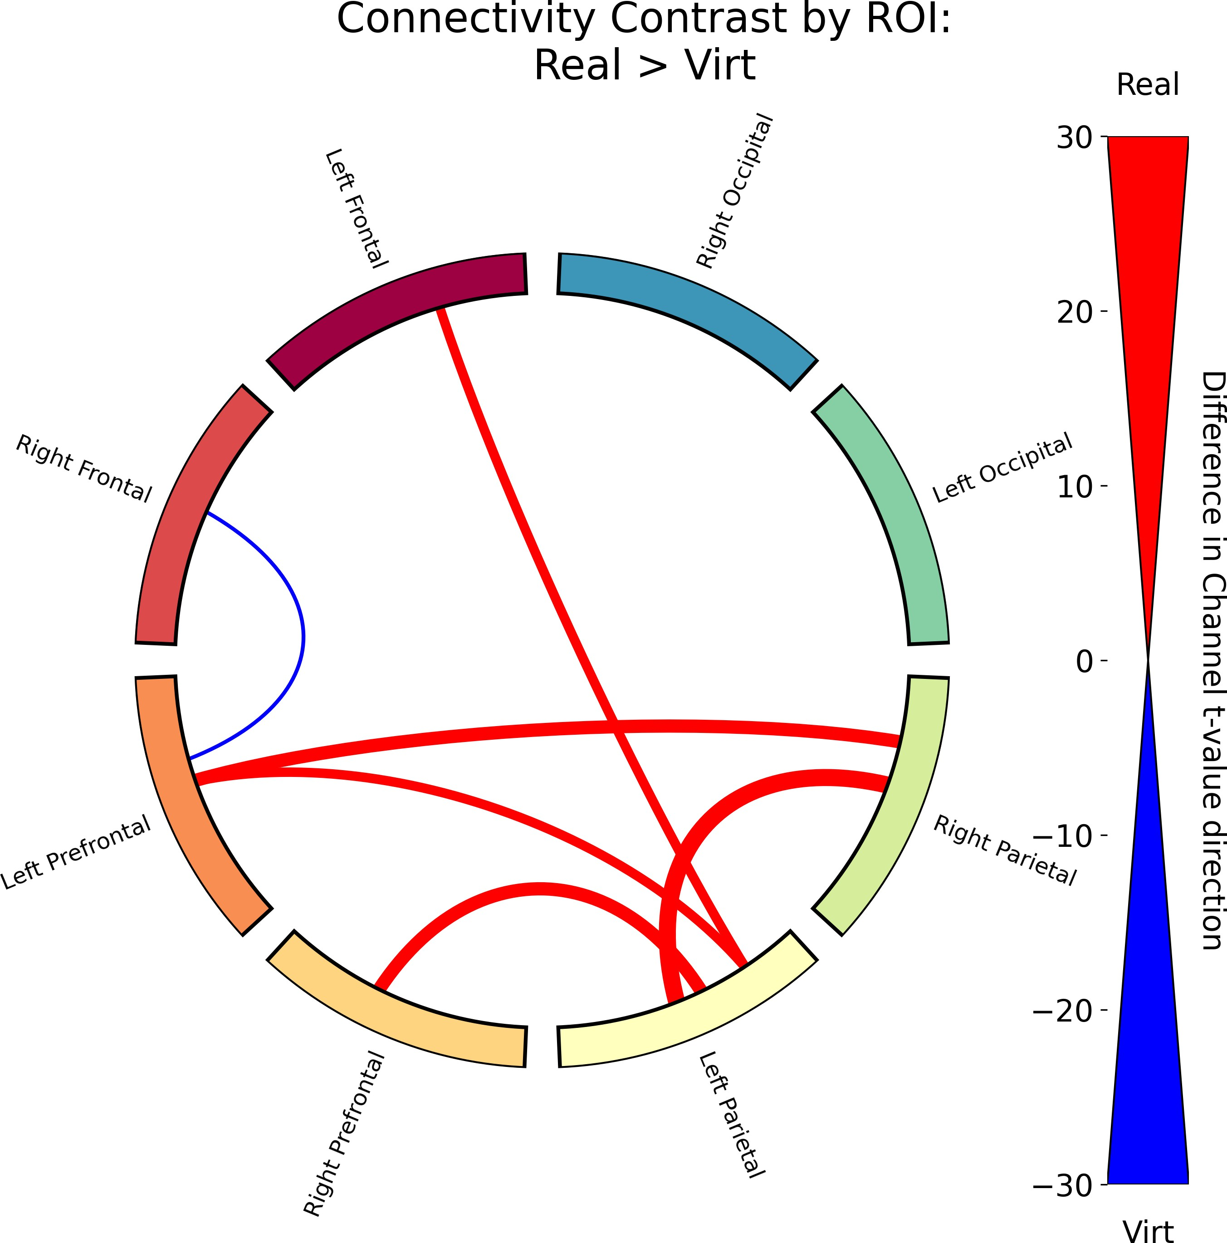

Figure 3.5: Functional connectivity results for the contrast between real and virtual conditions. The thickness of the lines represents the difference in the count of significantly different channel pairs between the two conditions. A red line signifies that condition 1 (real faces) had more significant channels between those two ROI’s where the *t*-value was positive, while a blue line signifies that condition 2 (virtual faces) had more significant channels between those two ROI’s where the *t*-value was negative. For clarity, only the top 15th percentile of connections (those with the most significant different channel pairs) are displayed for all functional connectivity contrasts.

#### Functional connectivity in response to emotion

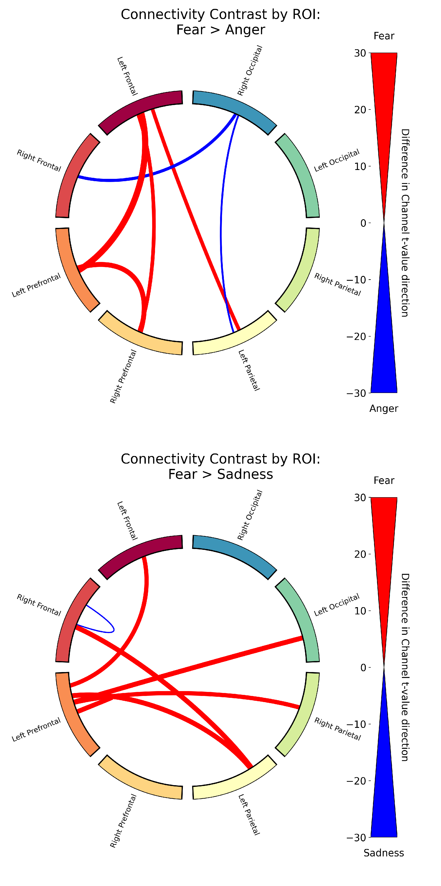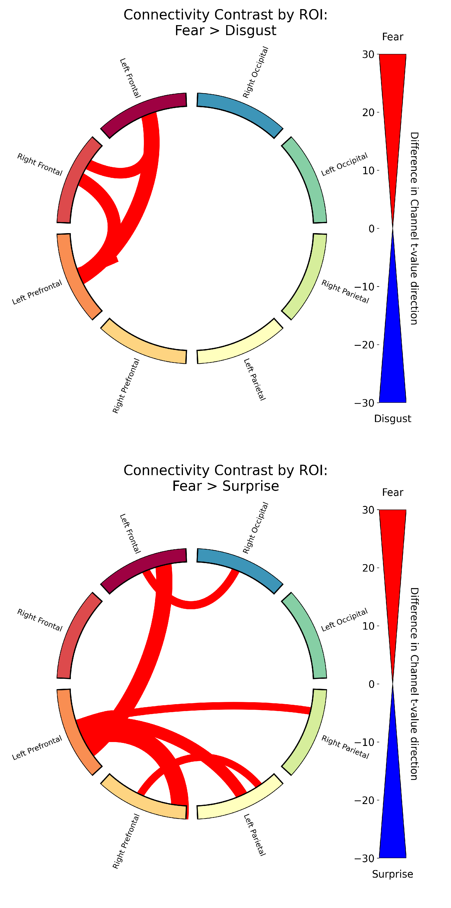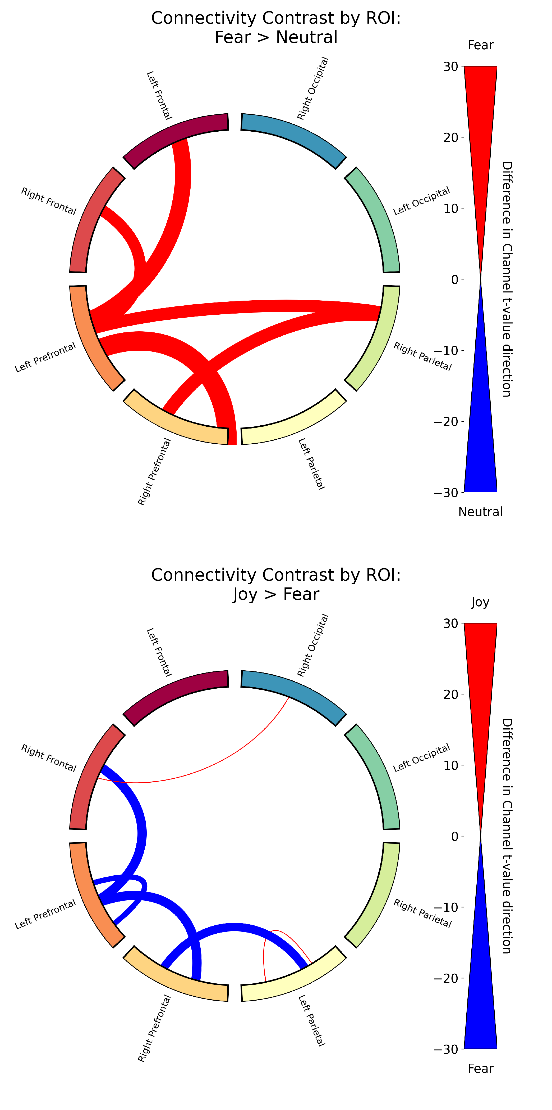We also found significant differences in functional connectivity in response to different emotions across all ROI’s. Figure 3.6 is a sample of the functional connectivity results for the contrasts between Fear and the other emotions. We found that processing Fear had significantly higher connectivity compared to processing Disgust, Neutral, Sadness, Surprise, and Joy, but only slightly higher connectivity compared to processing Anger. The remaining list of functional connectivity contrasts for all emotions can be found in Appendix B.

Figure 3.6: Functional connectivity results for Fear relative to the other emotions.

All functional connectivity results represented as the average *t*-value for all significant connections across the brain for each pairwise emotion contrasts are plotted as a heatmap (Figure 3.7). We found processing Anger and Fear had the highest connectivity compared to the other emotions, with processing Fear having slightly higher connectivity than Anger. Processing Joy also had higher connectivity compared to processing Neutral and

Surprise, but lower connectivity compared to processing Anger and Fear. This lines up with Figure 3.6, which shows that processing Anger and Fear have higher connectivity relative to the other emotions.

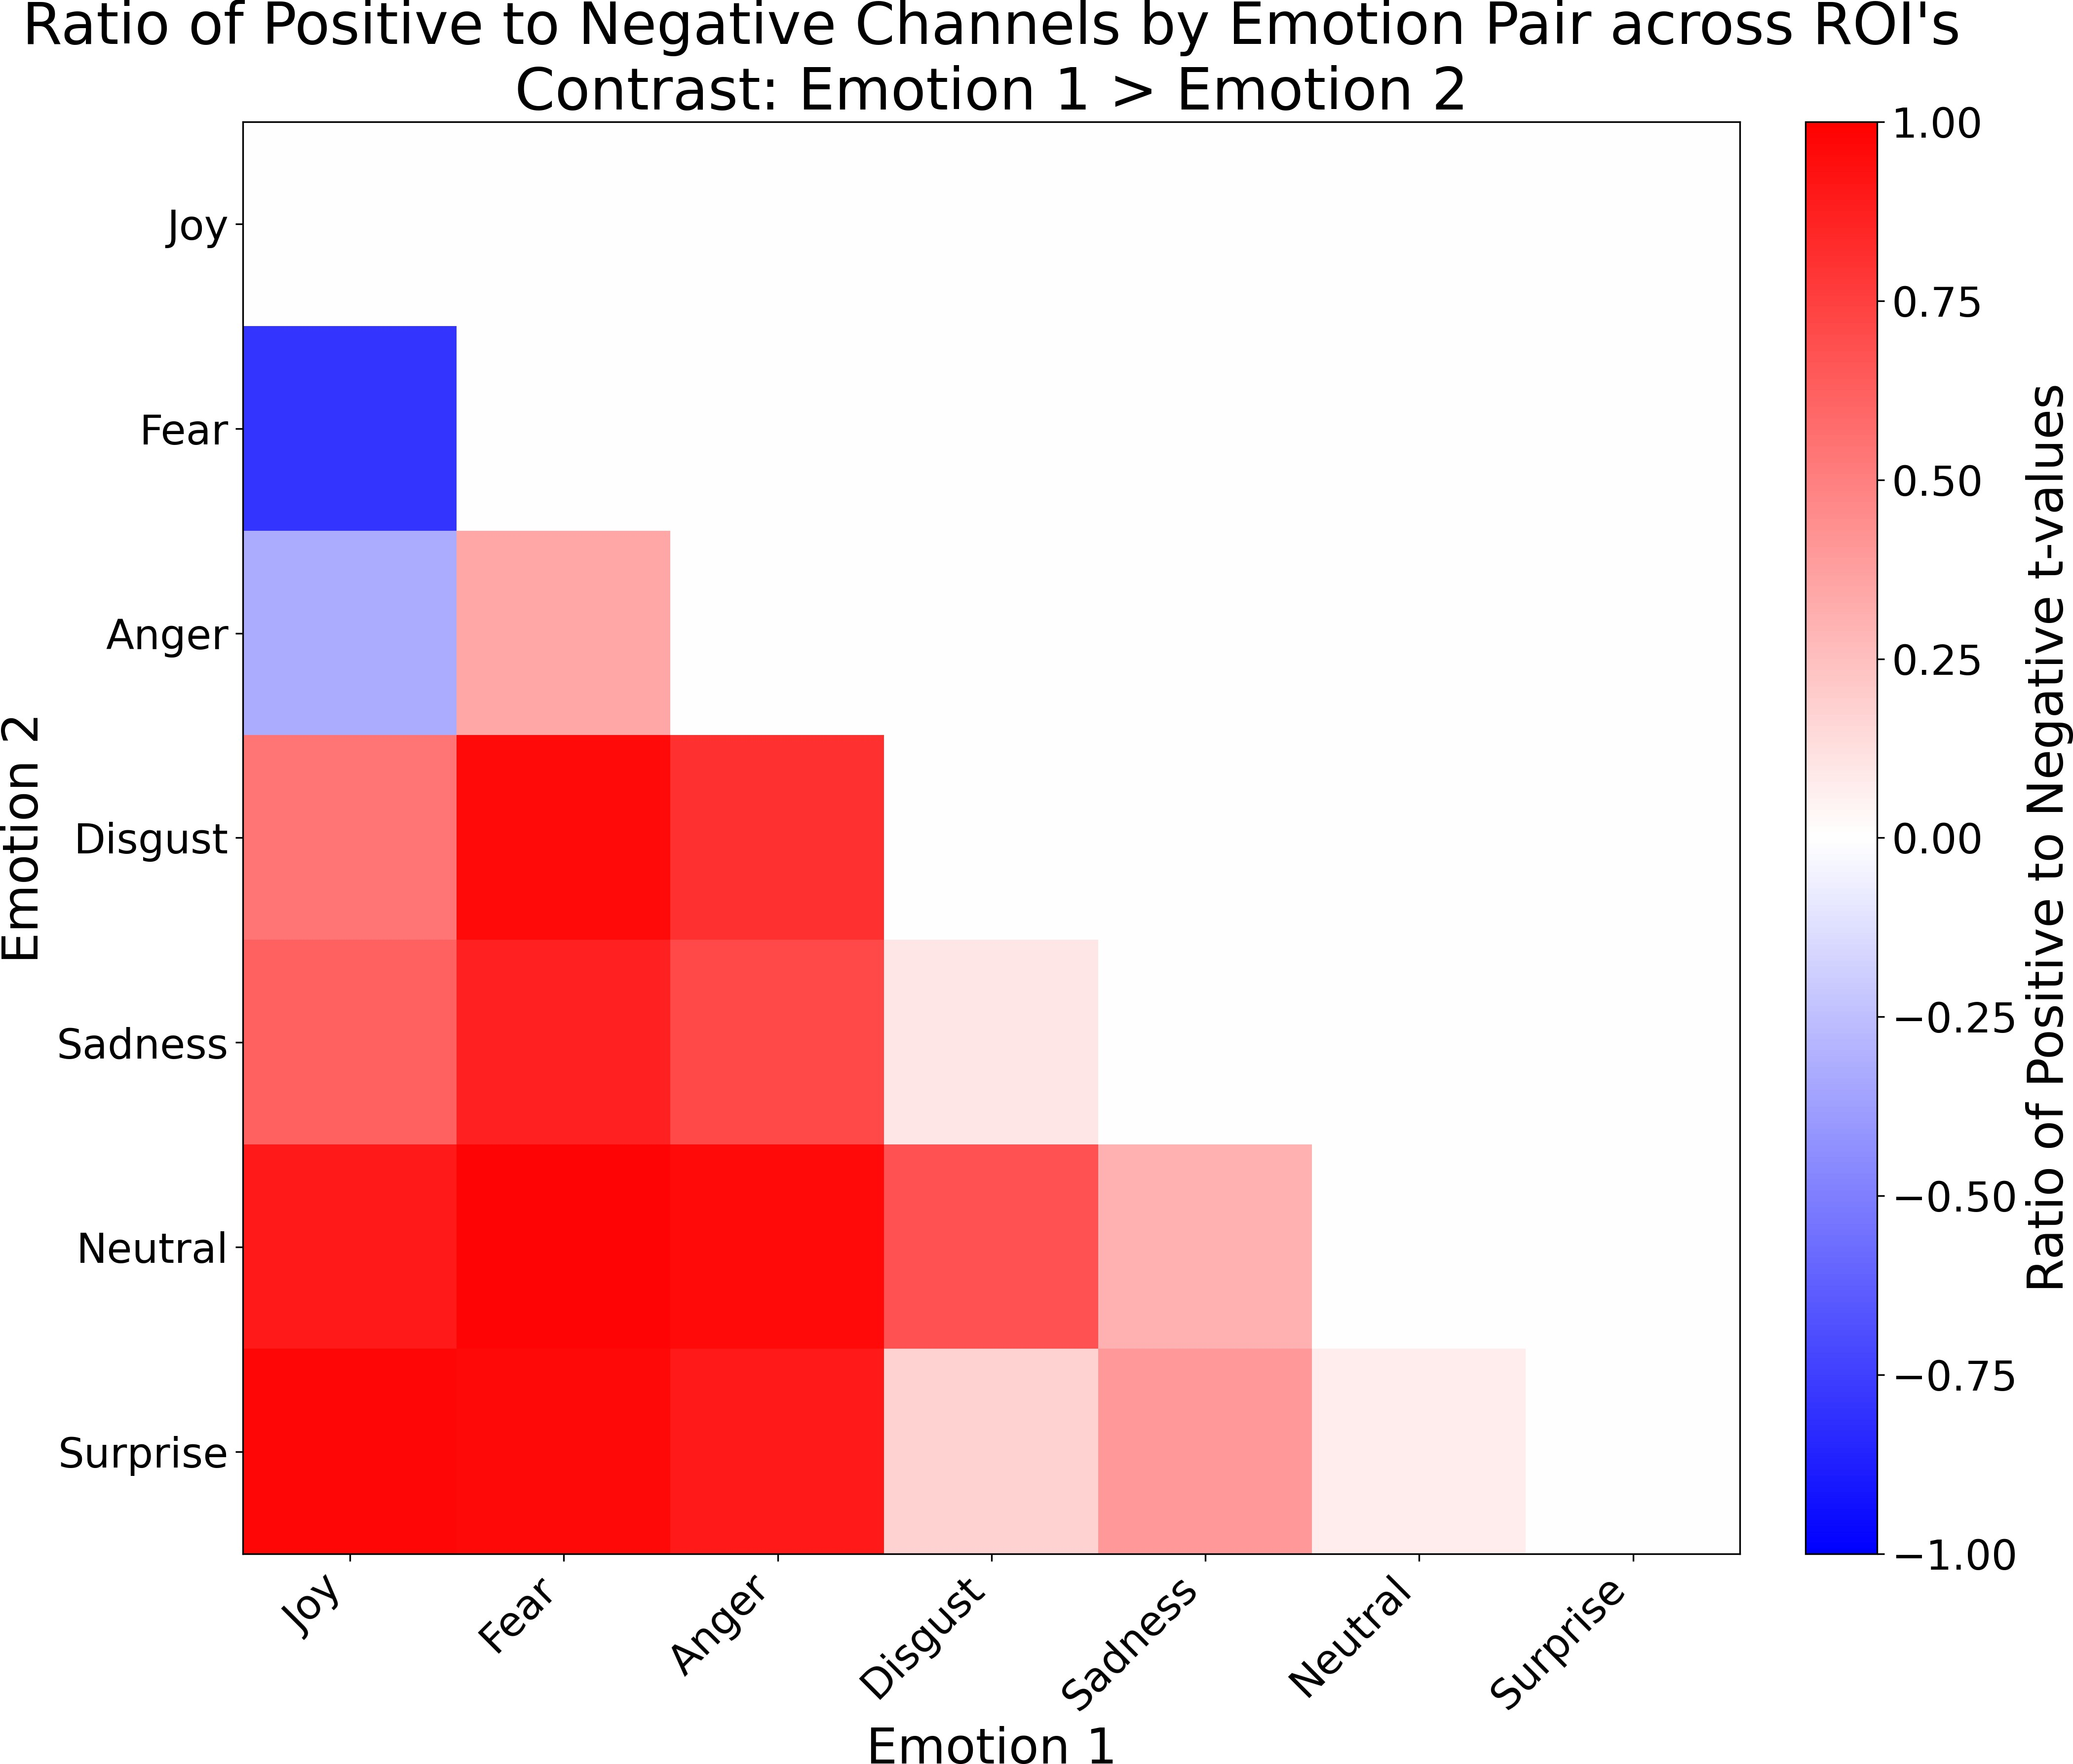

Figure 3.7: A heatmap summary of the functional connectivity results for the contrasts between different emotions across ROI’s. Red signifies that emotion 1 had a higher ratio of significant channels where the *t*-value was positive, while blue signifies that emotion 2 had a higher ratio of significant channels where the *t*-value was negative. The ratio was calculated by taking the difference of the count of significant channels where the *t*-value was positive and the count of significant channels where the *t*-value was negative, and dividing it by the total number of significant channels for that emotion pair.

To quantify the degree to which ROI’s differed across emotion based contrasts, sig- nificant channels across the brain were summed and plotted as a heatmap (Figure 3.8). Two regions, left occipital and right occipital, (marked with an asterisk (*)), produced the least number of significant connections, suggesting that the connectivity within and between these regions are very similar in response to all emotions and that neural in-

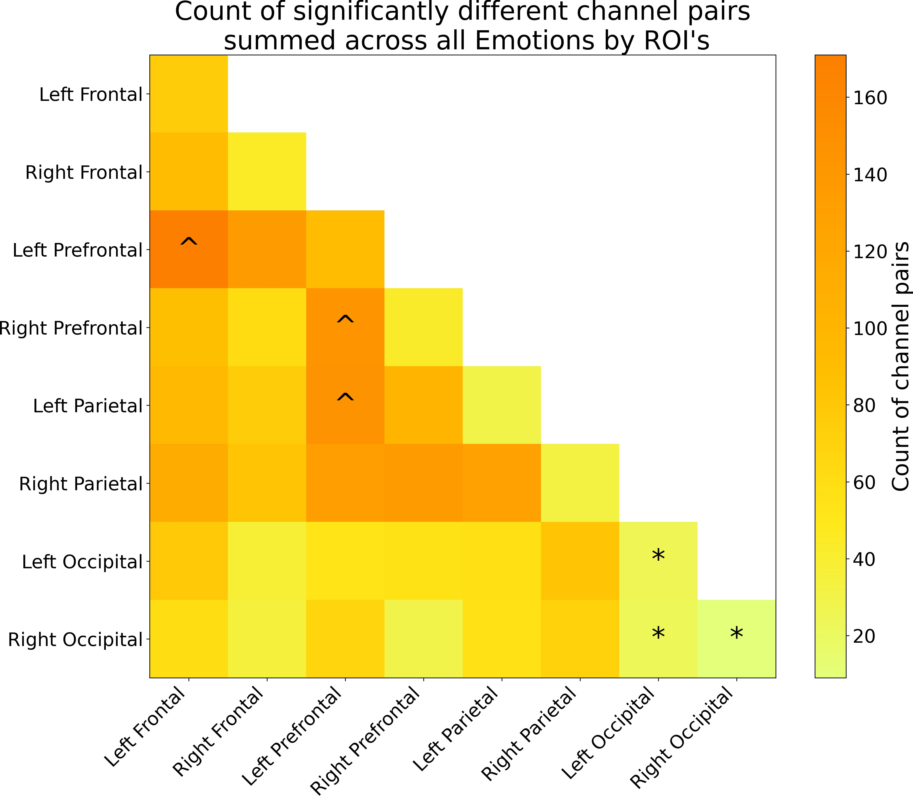dices that differentiate emotion processing likely occur in brain regions outside of visual cortex. Three regions, left prefrontal, left parietal, and right prefrontal (marked with a caret (ˆ)), produced the most number of significant connections, suggesting that these regions are more variable in their connectivity patterns across emotions.

Figure 3.8: A heatmap summary of the number of significantly different channel pairs for each ROI summed across all emotions. The color bar on the right shows the number of significant channel pairs for each ROI, with brighter colors indicating a smaller number of significant channel pairs, and darker colors indicating a larger number of significant channel pairs. An asterisk (*) was placed on the 3 ROI’s with the least number of significantly different channel pairs to indicate that these ROI’s are more synchronized with each other than any other pair of ROI’s, regardless of the emotion. A caret (ˆ) was placed on the 3 ROI’s with the most number of significantly different channel pairs to indicate that these ROI’s are less synchronized with each other than any other pair of ROI’s, regardless of the emotion. Note that ROI’s can have differences within them, as each ROI is made up of multiple channels, and the differences are calculated between channels within the same ROI.

#### Differential Functional connectivity profiles in response to emotion across face type

The interaction of face type with emotion, Real *>* Virtual within each emotion (Figure 3.9) revealed significant differences in functional connectivity across the brain. That is processing Anger, Disgust, Fear, and Neutral expressions on virtual faces produced higher connectivity across most ROI’s compared to real faces. Conversely, processing Joy, Sadness, and Surprise on real faces produced higher connectivity across most ROI’s compared to virtual faces. Like the GLM results, this indicates that the neural response to emotional expressions is modulated by the realism of the face stimuli. The full table of the functional connectivity contrasts for all main effects and interactions can be found in Appendix B.

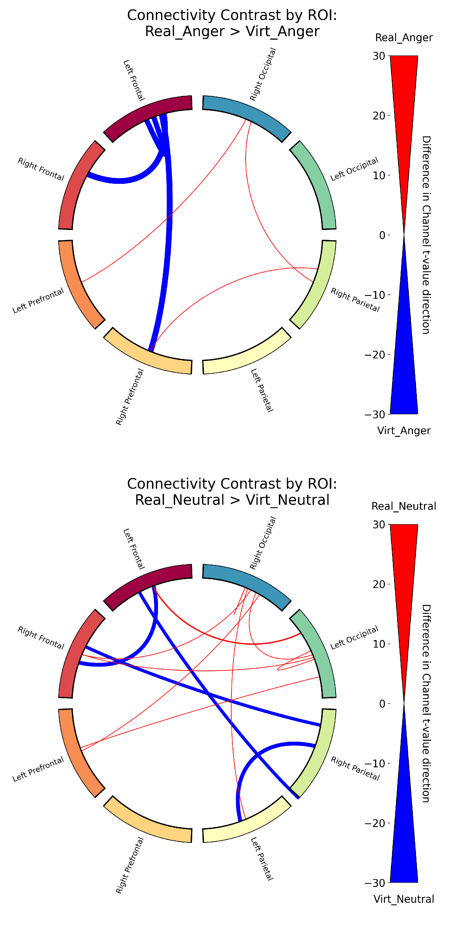 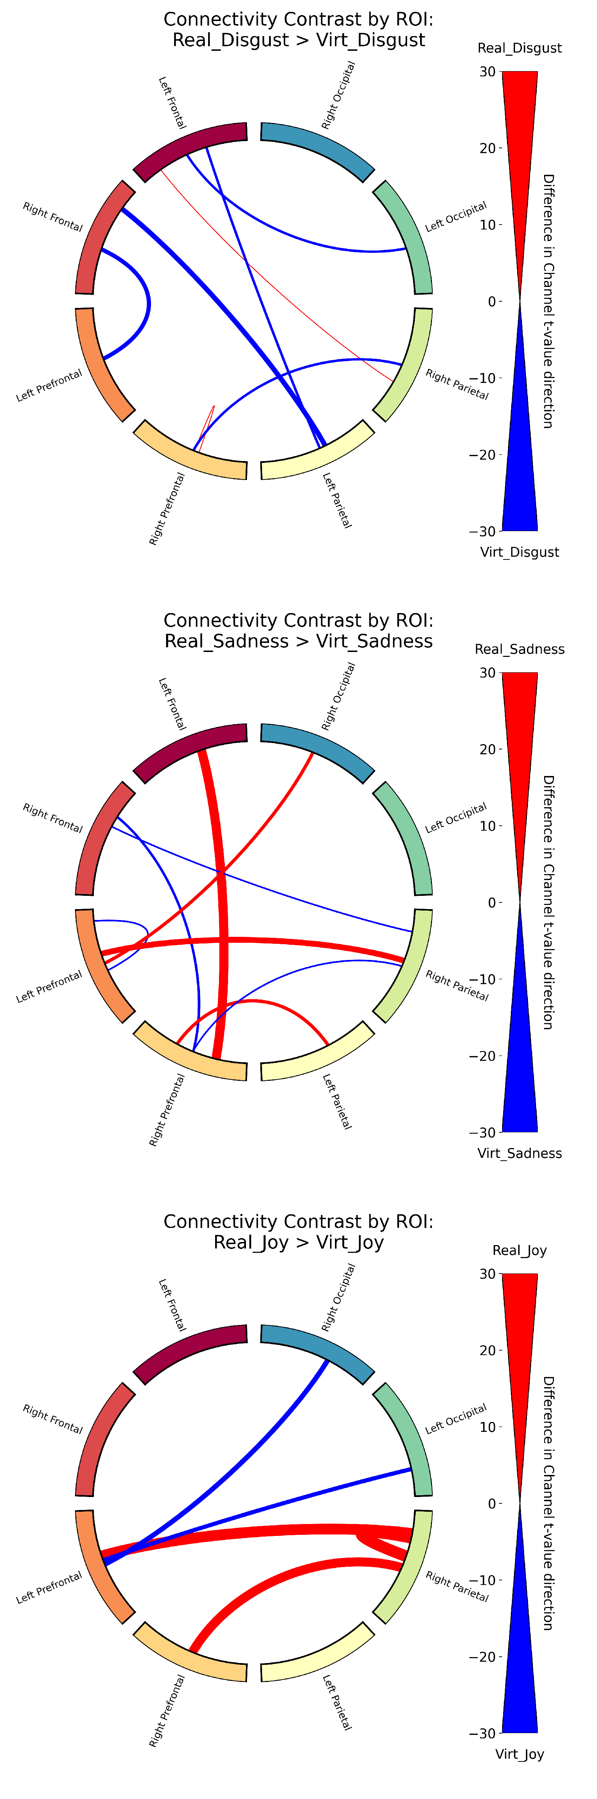 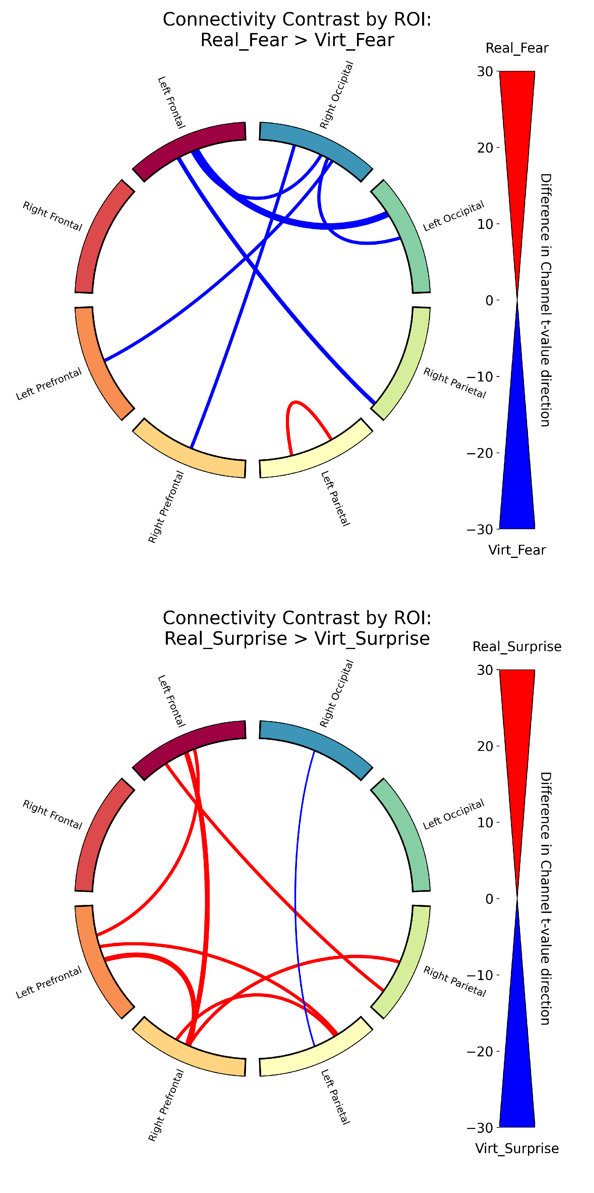

Figure 3.9: Functional connectivity results for the contrast between real and virtual conditions within each emotion.

## Memory Task Results

A two-way Type III ANOVA revealed a significant main effect of face type, *F* (1*,* 4802) = 7*.*96, *p* = 0*.*0048, indicating that memory performance was higher for real faces com- pared to virtual faces, as shown in Figure 3.10. There was no significant main effect of emotion, *F* (6*,* 4802) = 0*.*83, *p* = 0*.*55, nor a significant interaction between face type and

emotion, *F* (6*,* 4802) = 0*.*46, *p* = 0*.*84. These findings suggest that while the realism of the face influences memory performance, the specific emotional expression does not have a significant impact on memory accuracy. The full ANOVA table is shown in Appendix C.1.

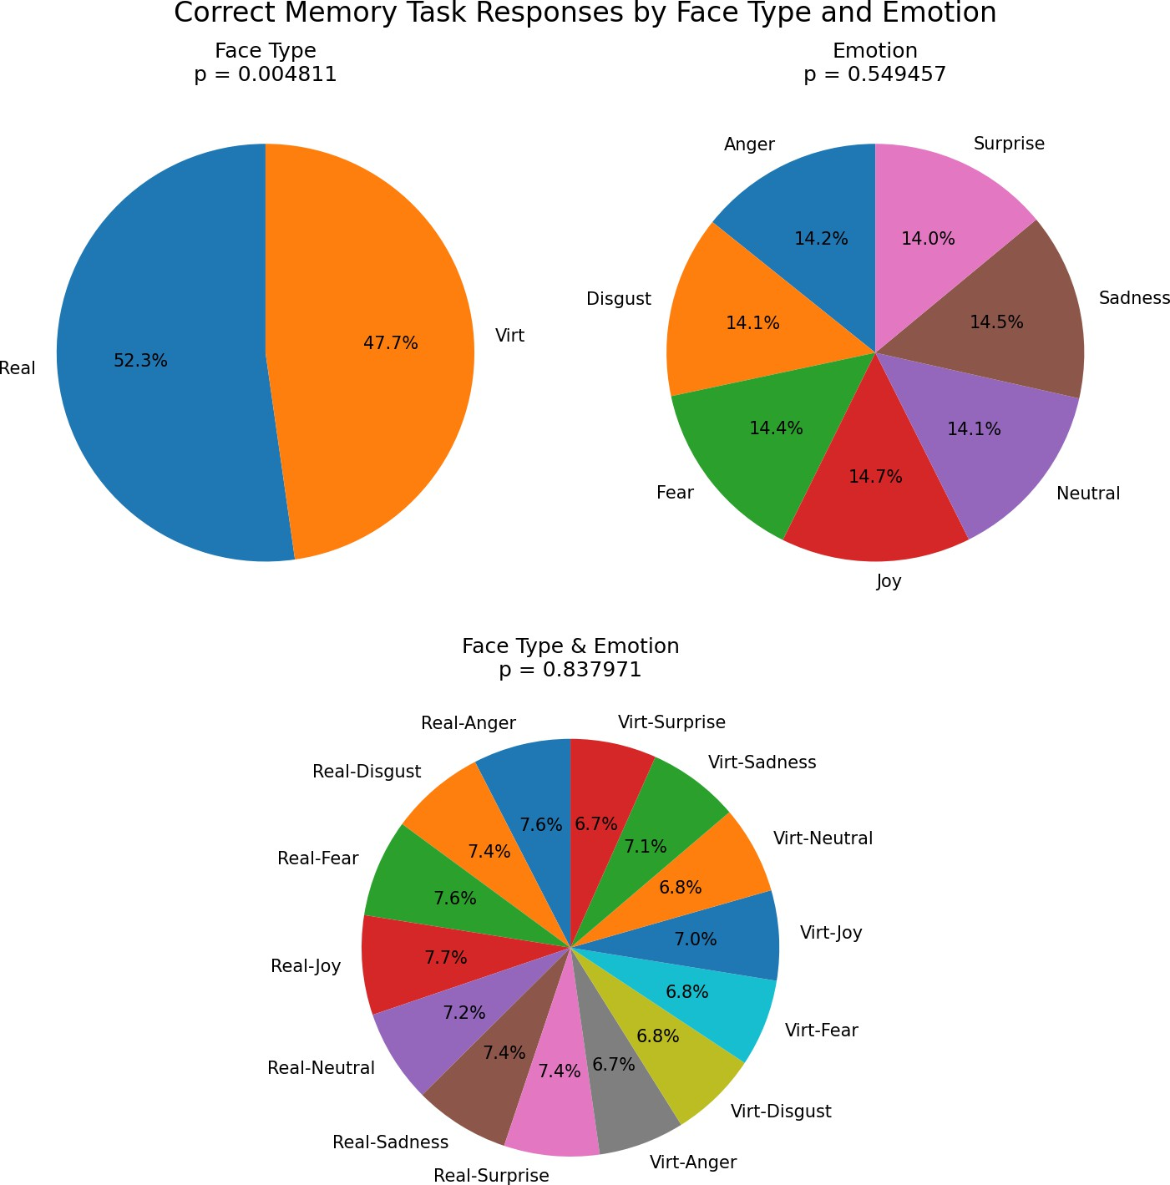

Figure 3.10: Proportion correct by condition in the memory task, plotted separately for real and virtual faces, for each emotion, and the interaction between face type and emotion. The *p*-values indicate the significance of the main effects and interaction.

# Discussion

## Limitations and Future Directions

## Conclusion

Bastos, A. M. and Schoffelen, J.-M. (2016). A Tutorial Review of Functional Con- nectivity Analysis Methods and Their Interpretational Pitfalls. *Frontiers in Systems Neuroscience*, 9. Publisher: Frontiers. 2.4.3

Bergmann, T., Froese, L., Gomez, A., Sainbhi, A. S., Vakitbilir, N., Islam, A., Stein, K., Marquez, I., Amenta, F., Park, K., Ibrahim, Y., and Zeiler, F. A. (2023). Evaluation of Morlet Wavelet Analysis for Artifact Detection in Low-Frequency Commercial Near- Infrared Spectroscopy Systems. *Bioengineering*, 11(1):0. 2.4.3

Bulgarelli, C., Blasi, A., McCann, S., Milosavljevic, B., Ghillia, G., Mbye, E., Touray, E., Fadera, T., Acolatse, L., Moore, S. E., Lloyd-Fox, S., Elwell, C. E., Eggebrecht,

A. T., and Team, t. B. S. (2025). Growth in early infancy drives optimal brain functional connectivity which predicts cognitive flexibility in later childhood. Pages: 2024.01.02.573930 Section: New Results. 2.1

Conley, M. I., Dellarco, D. V., Rubien-Thomas, E., Cohen, A. O., Cervera, A., Totten- ham, N., and Casey, B. (2018). The racially diverse affective expression (RADIATE) face stimulus set. *Psychiatry Research*, 270:1059–1067. 2.2.1

Cui, X., Bray, S., and Reiss, A. L. (2010). Functional near infrared spectroscopy (NIRS) signal improvement based on negative correlation between oxygenated and deoxy- genated hemoglobin dynamics. *NeuroImage*, 49(4):3039–3046. 2.4.1

Ekman, P. (1992). Are there basic emotions? *Psychological Review*, 99(3):550–553. Place: US Publisher: American Psychological Association. 2.2.1

Fishburn, F. A., Ludlum, R. S., Vaidya, C. J., and Medvedev, A. V. (2019). Tempo- ral Derivative Distribution Repair (TDDR): A motion correction method for fNIRS. *NeuroImage*, 184:171–179. 2.4.1

Friston, K. J. (2007). *Statistical parametric mapping: the analysis of functional brain images*. Elsevier / Academic Press, Amsterdam Boston, 1st ed edition. 2.4.2

Gramfort, A., Luessi, M., Larson, E., Engemann, D. A., Strohmeier, D., Brodbeck, C., Goj, R., Jas, M., Brooks, T., Parkkonen, L., and H¨am¨al¨ainen, M. (2013). MEG and EEG data analysis with MNE-Python. *Frontiers in Neuroscience*, 7. Publisher: Frontiers. 2.4

Hakim, U., De Felice, S., Pinti, P., Zhang, X., Noah, J., Ono, Y., Burgess, P. W., Hamil- ton, A., Hirsch, J., and Tachtsidis, I. (2023). Quantification of inter-brain coupling: A review of current methods used in haemodynamic and electrophysiological hyperscan- ning studies. *NeuroImage*, 280:120354. 2.4.3

Hernandez, S. M. and Pollonini, L. (2020). NIRSplot: A Tool for Quality Assessment of fNIRS Scans. In *Biophotonics Congress: Biomedical Optics 2020 (Translational, Microscopy, OCT, OTS, BRAIN)*, page BM2C.5, Washington, DC. Optica Publishing Group. 2.1

Hocke, L. M., Oni, I. K., Duszynski, C. C., Corrigan, A. V., Frederick, B. D., and Dunn,

J. F. (2018). Automated Processing of fNIRS Data—A Visual Guide to the Pitfalls and Consequences. *Algorithms*, 11(5):67. Number: 5 Publisher: Multidisciplinary Digital Publishing Institute. 2.4.1

Holmes, M., Aalto, D., and Cummine, J. (2024). Opening the dialogue: A preliminary

exploration of hair color, hair cleanliness, light, and motion effects on fNIRS signal quality. *PLOS ONE*, 19(5):e0304356. Publisher: Public Library of Science. 2.1

Hu, P., Wang, P., Zhao, R., Yang, H., and Biswal, B. B. (2023). Characterizing the spatiotemporal features of functional connectivity across the white matter and gray matter during the naturalistic condition. *Frontiers in Neuroscience*, 17. Publisher: Frontiers. 2.4.3

Kinder, K. T., Heim, H. L. R., Parker, J., Lowery, K., McCraw, A., Eddings, R. N., Defenderfer, J., Sullivan, J., and Buss, A. T. (2022). Systematic review of fNIRS studies reveals inconsistent chromophore data reporting practices. *Neurophotonics*, 9(4):040601. 2.4.1

Kocsis, L., Herman, P., and Eke, A. (2006). The modified Beer–Lambert law revisited.

*Physics in Medicine & Biology*, 51(5):N91. 2.4.1

Lindquist, K. A., Wager, T. D., Kober, H., Bliss-Moreau, E., and Barrett, L. F. (2012). The brain basis of emotion: A meta-analytic review. *Behavioral and Brain Sciences*, 35(3):121–143. 2.2.2

Luke, R., Larson, E. D., Shader, M. J., Innes-Brown, H., Yper, L. V., Lee, A. K. C., Sowman, P. F., and McAlpine, D. (2021). Analysis methods for measuring passive auditory fNIRS responses generated by a block-design paradigm. *Neurophotonics*, 8(2):025008. Publisher: SPIE. 2.4, 2.4.2

Miranda de S´a, A. M. F. L., Ferreira, D. D., Dias, E. W., Mendes, E. M. A. M., and Felix, L. B. (2009). Coherence estimate between a random and a periodic signal: Bias, variance, analytical critical values, and normalizing transforms. *Journal of the Franklin Institute*, 346(9):841–853. 2.4.3

Oliver, M. M. and Amengual Alcover, E. (2020). UIBVFED: Virtual facial expression dataset. *PLOS ONE*, 15(4):e0231266. 2.2.1

Peirce, J., Gray, J. R., Simpson, S., MacAskill, M., H¨ochenberger, R., Sogo, H., Kastman, E., and Lindeløv, J. K. (2019). PsychoPy2: Experiments in behavior made easy. *Behavior Research Methods*, 51(1):195–203. 2.2.2

Pinti, P., Scholkmann, F., Hamilton, A., Burgess, P., and Tachtsidis, I. (2019). Current Status and Issues Regarding Pre-processing of fNIRS Neuroimaging Data: An Investi- gation of Diverse Signal Filtering Methods Within a General Linear Model Framework. *Frontiers in Human Neuroscience*, 12. 2.4.1

Pollonini, L., Bortfeld, H., and Oghalai, J. S. (2016). PHOEBE: a method for real time mapping of optodes-scalp coupling in functional near-infrared spectroscopy. *Biomedical Optics Express*, 7(12):5104–5119. Publisher: Optica Publishing Group. 2.1

Reddy, P., Izzetoglu, M., Shewokis, P. A., Sangobowale, M., Diaz-Arrastia, R., and Izzetoglu, K. (2021). Evaluation of fNIRS signal components elicited by cognitive and hypercapnic stimuli. *Scientific Reports*, 11(1):23457. Publisher: Nature Publishing Group. 2.4.3

Scholkmann, F., Metz, A. J., and Wolf, M. (2014). Measuring tissue hemodynamics and oxygenation by continuous-wave functional near-infrared spectroscopy—how ro- bust are the different calculation methods against movement artifacts? *Physiological Measurement*, 35(4):717. Publisher: IOP Publishing. 2.4.1

Seabold, S. and Perktold, J. (2010). statsmodels: Econometric and statistical modeling with python. In *9th Python in Science Conference*. 2.4

Singh, A. K. and Dan, I. (2006). Exploring the false discovery rate in multichannel NIRS.

*NeuroImage*, 33(2):542–549. 2.4.2, 2.4.3

Tachtsidis, I. and Scholkmann, F. (2016). False positives and false negatives in functional near-infrared spectroscopy: issues, challenges, and the way forward. *Neurophotonics*, 3(3):031405. Publisher: SPIE. 2.4.1

Xu, G., Zhang, M., Wang, Y., Liu, Z., Huo, C., Li, Z., and Huo, M. (2017). Functional connectivity analysis of distracted drivers based on the wavelet phase coherence of functional near-infrared spectroscopy signals. *PLOS ONE*, 12(11):e0188329. Publisher: Public Library of Science. 2.4.3

# Appendix A GLM Contrasts

Table A.1: Table of contrast results from the GLM analysis.

|  |  |  |  |  |  |  |
| --- | --- | --- | --- | --- | --- | --- |
| Contrast | Region | Ch Name | Coef. | Std.Err. | *z* | *pfdr* |

|  |  |  |  |  |  |  |
| --- | --- | --- | --- | --- | --- | --- |
| Real *>* Virtual | Left Occipital | S23 D15 hbt | -1.550 | 0.394 | -3.937 | 0.009 |
| Joy *>* Neutral | Right Parietal | S20 D29 hbt | 2.611 | 0.623 | 4.194 | 0.001 |
| Joy *>* Neutral | Right Occipital | S23 D30 hbt | -3.144 | 0.623 | -5.050 | 0.000 |
| Joy *>* Surprise | Right Occipital | S23 D16 hbt | -2.884 | 0.647 | -4.460 | 0.001 |
| Joy *>* Surprise | Left Prefrontal | S25 D6 hbt | -2.379 | 0.647 | -3.679 | 0.012 |
| Fear *>* Neutral | Right Occipital | S23 D30 hbt | -2.126 | 0.557 | -3.819 | 0.014 |
| Fear *>* Surprise | Right Parietal | S20 D29 hbt | -2.048 | 0.568 | -3.606 | 0.032 |
| Anger *>* Neutral | Right Occipital | S23 D30 hbt | -3.620 | 0.652 | -5.547 | 0.000 |
| Disgust *>* Surprise | Right Occipital | S23 D16 hbt | -2.507 | 0.640 | -3.920 | 0.005 |
| Disgust *>* Surprise | Left Prefrontal | S25 D6 hbt | -2.531 | 0.640 | -3.958 | 0.005 |
| Sadness *>* Neutral | Left Frontal | S4 D6 hbt | -2.257 | 0.601 | -3.754 | 0.018 |
| Sadness *>* Surprise | Left Frontal | S4 D6 hbt | -2.610 | 0.673 | -3.879 | 0.011 |
| Sadness *>* Surprise | Right Parietal | S20 D29 hbt | -2.304 | 0.673 | -3.425 | 0.032 |

Continued on next page

33

|  |  |  |  |  |  |  |
| --- | --- | --- | --- | --- | --- | --- |
| Contrast | Region | Ch Name | Coef. | Std.Err. | *z* | *pfdr* |

|  |  |  |  |  |  |  |
| --- | --- | --- | --- | --- | --- | --- |
| Neutral *>* Surprise | Right Parietal | S20 D29 hbt | -2.653 | 0.625 | -4.247 | 0.002 |
| Neutral *>* Surprise | Right Occipital | S23 D30 hbt | 2.461 | 0.625 | 3.940 | 0.004 |
| Real Joy *>* Real Disgust | Right Occipital | S23 D30 hbt | -5.344 | 1.093 | -4.889 | 0.000 |
| Real Joy *>* Real Sadness | Right Occipital | S24 D30 hbt | -3.816 | 0.964 | -3.958 | 0.008 |
| Real Joy *>* Real Neutral | Right Occipital | S23 D30 hbt | -5.786 | 0.980 | -5.906 | 0.000 |
| Real Joy *>* Real Surprise | Right Frontal | S9 D19 hbt | 3.093 | 0.997 | 3.101 | 0.050 |
| Real Joy *>* Real Surprise | Left Occipital | S23 D15 hbt | -3.754 | 0.997 | -3.764 | 0.017 |
| Real Joy *>* Real Surprise | Right Occipital | S23 D16 hbt | -3.577 | 0.997 | -3.587 | 0.017 |
| Real Joy *>* Real Surprise | Left Prefrontal | S25 D6 hbt | -3.293 | 0.997 | -3.302 | 0.033 |
| Real Joy *>* Virtual Joy | Left Occipital | S32 D15 hbt | 3.484 | 0.966 | 3.607 | 0.032 |
| Real Joy *>* Virtual Fear | Left Occipital | S23 D15 hbt | -3.384 | 0.965 | -3.506 | 0.023 |
| Real Joy *>* Virtual Fear | Right Occipital | S23 D30 hbt | -3.649 | 0.965 | -3.781 | 0.016 |
| Real Joy *>* Virtual Disgust | Left Occipital | S23 D15 hbt | -4.428 | 0.986 | -4.490 | 0.001 |
| Real Joy *>* Virtual Sadness | Left Occipital | S23 D15 hbt | -4.435 | 0.973 | -4.556 | 0.001 |
| Real Joy *>* Virtual Surprise | Right Occipital | S23 D16 hbt | -3.197 | 0.949 | -3.368 | 0.039 |
| Real Joy *>* Virtual Surprise | Right Occipital | S23 D30 hbt | -3.410 | 0.949 | -3.593 | 0.034 |
| Real Fear *>* Real Disgust | Right Occipital | S23 D30 hbt | -4.918 | 1.087 | -4.522 | 0.001 |
| Real Fear *>* Real Neutral | Right Occipital | S23 D30 hbt | -5.360 | 0.980 | -5.470 | 0.000 |
| Real Fear *>* Virtual Joy | Left Prefrontal | S25 D6 hbt | 4.150 | 1.054 | 3.938 | 0.008 |
| Real Fear *>* Virtual Disgust | Left Occipital | S23 D15 hbt | -4.112 | 1.009 | -4.073 | 0.002 |
| Real Fear *>* Virtual Disgust | Left Prefrontal | S25 D6 hbt | 4.183 | 1.009 | 4.144 | 0.002 |
| Real Fear *>* Virtual Sadness | Left Occipital | S23 D15 hbt | -4.119 | 1.003 | -4.109 | 0.004 |
| Real Fear *>* Virtual Sadness | Left Prefrontal | S25 D6 hbt | 3.595 | 1.003 | 3.585 | 0.017 |

|  |  |  |  |  |  |  |
| --- | --- | --- | --- | --- | --- | --- |
| Contrast | Region | Ch Name | Coef. | Std.Err. | *z* | *pfdr* |

|  |  |  |  |  |  |  |
| --- | --- | --- | --- | --- | --- | --- |
| Real Anger *>* Real Disgust | Right Occipital | S23 D30 hbt | -4.697 | 1.117 | -4.205 | 0.003 |
| Real Anger *>* Real Neutral | Right Occipital | S23 D30 hbt | -5.139 | 0.983 | -5.226 | 0.000 |
| Real Disgust *>* Real Surprise | Left Frontal | S4 D6 hbt | -3.742 | 1.107 | -3.380 | 0.025 |
| Real Disgust *>* Real Surprise | Left Occipital | S23 D15 hbt | -4.679 | 1.107 | -4.226 | 0.002 |
| Real Disgust *>* Real Surprise | Right Occipital | S23 D30 hbt | 4.221 | 1.107 | 3.813 | 0.007 |
| Real Disgust *>* Virtual Fear | Left Occipital | S23 D15 hbt | -4.309 | 1.013 | -4.252 | 0.002 |
| Real Disgust *>* Virtual Disgust | Left Occipital | S23 D15 hbt | -5.353 | 1.163 | -4.603 | 0.000 |
| Real Disgust *>* Virtual Disgust | Right Occipital | S23 D30 hbt | 5.028 | 1.163 | 4.323 | 0.001 |
| Real Disgust *>* Virtual Sadness | Left Occipital | S23 D15 hbt | -5.360 | 1.163 | -4.608 | 0.000 |
| Real Disgust *>* Virtual Sadness | Right Occipital | S23 D30 hbt | 4.254 | 1.163 | 3.657 | 0.013 |
| Real Disgust *>* Virtual Neutral | Right Occipital | S23 D30 hbt | 3.878 | 1.102 | 3.520 | 0.044 |
| Real Sadness *>* Real Neutral | Right Occipital | S23 D30 hbt | -3.749 | 0.912 | -4.110 | 0.002 |
| Real Sadness *>* Real Neutral | Right Occipital | S24 D30 hbt | 4.012 | 0.912 | 4.398 | 0.001 |
| Real Sadness *>* Real Surprise | Left Frontal | S4 D6 hbt | -3.743 | 1.059 | -3.534 | 0.021 |
| Real Sadness *>* Real Surprise | Right Occipital | S24 D30 hbt | 4.688 | 1.059 | 4.426 | 0.001 |
| Real Sadness *>* Virtual Joy | Right Occipital | S24 D30 hbt | 3.811 | 1.048 | 3.638 | 0.028 |
| Real Sadness *>* Virtual Disgust | Left Occipital | S23 D15 hbt | -3.951 | 1.088 | -3.633 | 0.029 |
| Real Sadness *>* Virtual Sadness | Left Occipital | S23 D15 hbt | -3.959 | 1.051 | -3.766 | 0.017 |
| Real Neutral *>* Real Surprise | Right Parietal | S20 D29 hbt | -3.553 | 0.933 | -3.809 | 0.007 |
| Real Neutral *>* Real Surprise | Right Occipital | S23 D30 hbt | 4.663 | 0.933 | 4.999 | 0.000 |
| Real Neutral *>* Virtual Joy | Right Occipital | S23 D30 hbt | 3.563 | 0.924 | 3.856 | 0.012 |
| Real Neutral *>* Virtual Anger | Left Frontal | S4 D6 hbt | 4.371 | 1.009 | 4.330 | 0.002 |
| Real Neutral *>* Virtual Anger | Right Occipital | S23 D30 hbt | 3.737 | 1.009 | 3.702 | 0.011 |

|  |  |  |  |  |  |  |
| --- | --- | --- | --- | --- | --- | --- |
| Contrast | Region | Ch Name | Coef. | Std.Err. | *z* | *pfdr* |

|  |  |  |  |  |  |  |
| --- | --- | --- | --- | --- | --- | --- |
| Real Neutral *>* Virtual Disgust | Right Occipital | S23 D30 hbt | 5.470 | 1.020 | 5.365 | 0.000 |
| Real Neutral *>* Virtual Sadness | Left Frontal | S4 D6 hbt | 4.863 | 0.963 | 5.051 | 0.000 |
| Real Neutral *>* Virtual Sadness | Right Occipital | S23 D30 hbt | 4.696 | 0.963 | 4.877 | 0.000 |
| Real Neutral *>* Virtual Neutral | Right Occipital | S23 D30 hbt | 4.320 | 0.994 | 4.346 | 0.001 |
| Real Surprise *>* Virtual Joy | Left Frontal | S4 D6 hbt | 3.580 | 1.038 | 3.448 | 0.029 |
| Real Surprise *>* Virtual Joy | Left Prefrontal | S25 D6 hbt | 4.185 | 1.038 | 4.030 | 0.006 |
| Real Surprise *>* Virtual Anger | Left Frontal | S4 D6 hbt | 5.443 | 1.096 | 4.966 | 0.000 |
| Real Surprise *>* Virtual Anger | Right Frontal | S10 D17 hbt | -3.659 | 1.096 | -3.338 | 0.029 |
| Real Surprise *>* Virtual Anger | Left Occipital | S23 D15 hbt | 3.907 | 1.096 | 3.565 | 0.019 |
| Real Surprise *>* Virtual Disgust | Left Prefrontal | S25 D6 hbt | 4.218 | 1.042 | 4.048 | 0.005 |
| Real Surprise *>* Virtual Sadness | Left Frontal | S4 D6 hbt | 5.935 | 1.000 | 5.937 | 0.000 |
| Real Surprise *>* Virtual Sadness | Left Prefrontal | S7 D6 hbt | 3.660 | 1.000 | 3.661 | 0.007 |
| Real Surprise *>* Virtual Sadness | Right Parietal | S20 D29 hbt | 4.101 | 1.000 | 4.102 | 0.002 |
| Real Surprise *>* Virtual Sadness | Left Prefrontal | S25 D6 hbt | 3.630 | 1.000 | 3.631 | 0.007 |
| Real Surprise *>* Virtual Neutral | Left Frontal | S4 D6 hbt | 3.189 | 1.025 | 3.111 | 0.048 |
| Real Surprise *>* Virtual Neutral | Right Frontal | S9 D19 hbt | -3.357 | 1.025 | -3.275 | 0.048 |
| Real Surprise *>* Virtual Neutral | Right Parietal | S20 D29 hbt | 3.539 | 1.025 | 3.453 | 0.048 |
| Real Surprise *>* Virtual Neutral | Left Occipital | S31 D15 hbt | -3.254 | 1.025 | -3.174 | 0.048 |
| Virtual Joy *>* Virtual Disgust | Left Occipital | S32 D15 hbt | -4.343 | 1.008 | -4.308 | 0.002 |
| Virtual Fear *>* Virtual Disgust | Right Occipital | S23 D30 hbt | 3.333 | 0.928 | 3.590 | 0.034 |
| Virtual Fear *>* Virtual Sadness | Left Frontal | S4 D6 hbt | 3.597 | 1.021 | 3.522 | 0.044 |
| Virtual Anger *>* Virtual Disgust | Left Frontal | S4 D6 hbt | -3.633 | 1.033 | -3.518 | 0.019 |
| Virtual Anger *>* Virtual Disgust | Left Occipital | S23 D15 hbt | -4.581 | 1.033 | -4.436 | 0.001 |

|  |  |  |  |  |  |  |
| --- | --- | --- | --- | --- | --- | --- |
| Contrast | Region | Ch Name | Coef. | Std.Err. | *z* | *pfdr* |

|  |  |  |  |  |  |  |
| --- | --- | --- | --- | --- | --- | --- |
| Virtual Anger *>* Virtual Disgust | Left Prefrontal | S25 D6 hbt | 3.565 | 1.033 | 3.452 | 0.019 |
| Virtual Anger *>* Virtual Sadness | Left Occipital | S23 D15 hbt | -4.589 | 1.018 | -4.508 | 0.001 |
| Virtual Disgust *>* Virtual Sadness | Left Frontal | S4 D6 hbt | 4.125 | 1.044 | 3.950 | 0.008 |
| Virtual Disgust *>* Virtual Surprise | Left Occipital | S23 D15 hbt | 3.761 | 1.001 | 3.758 | 0.018 |
| Virtual Sadness *>* Virtual Surprise | Left Occipital | S23 D15 hbt | 3.768 | 0.978 | 3.853 | 0.012 |

38

# Appendix B

**Functional Connectivity Contrasts**

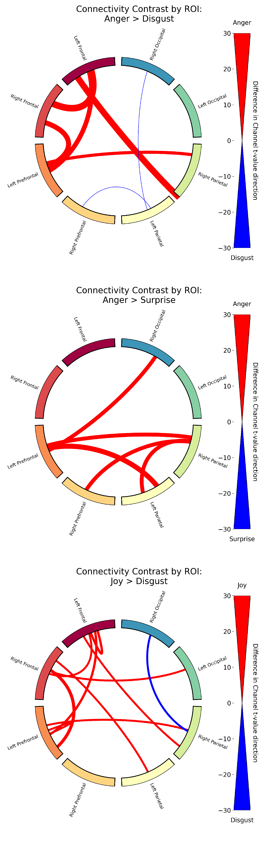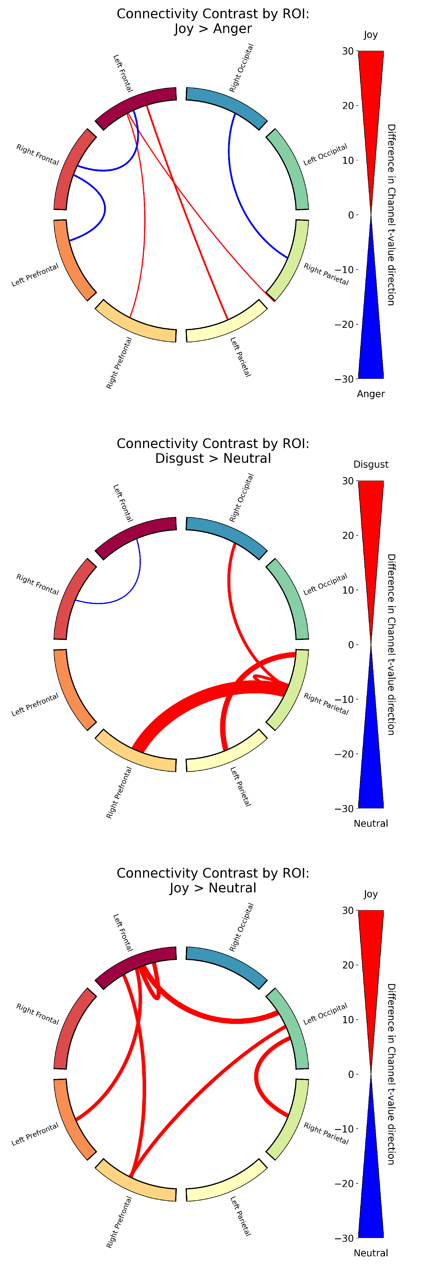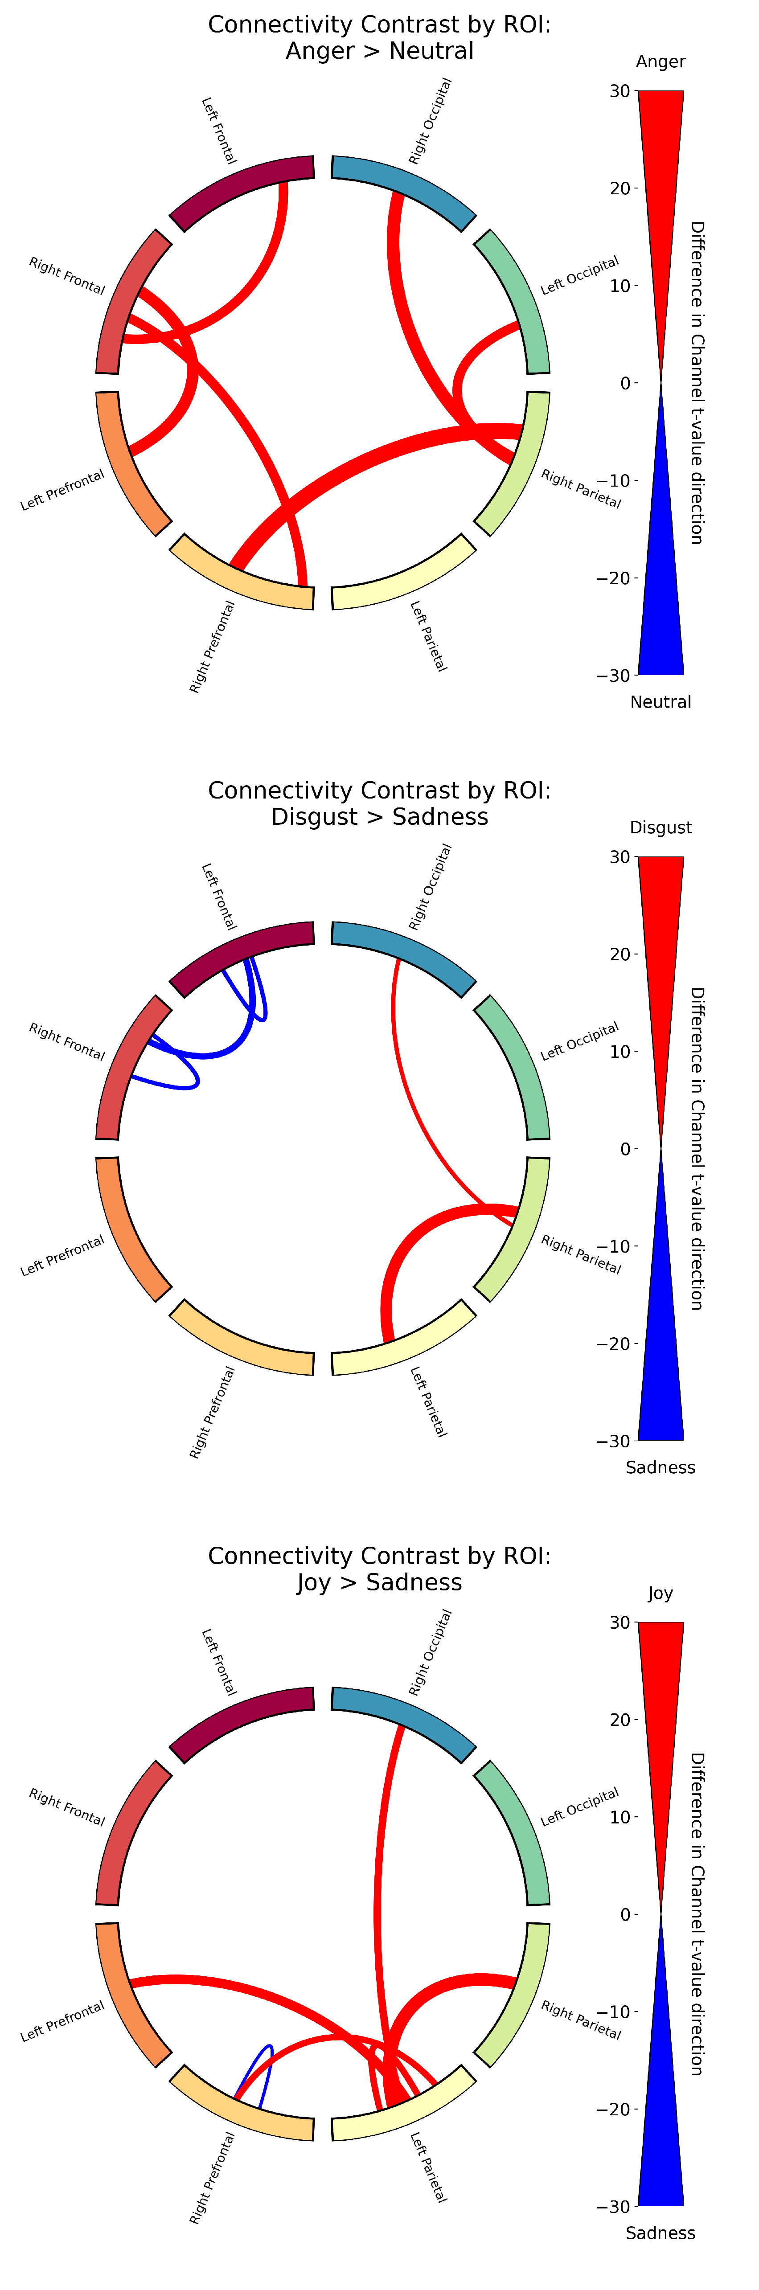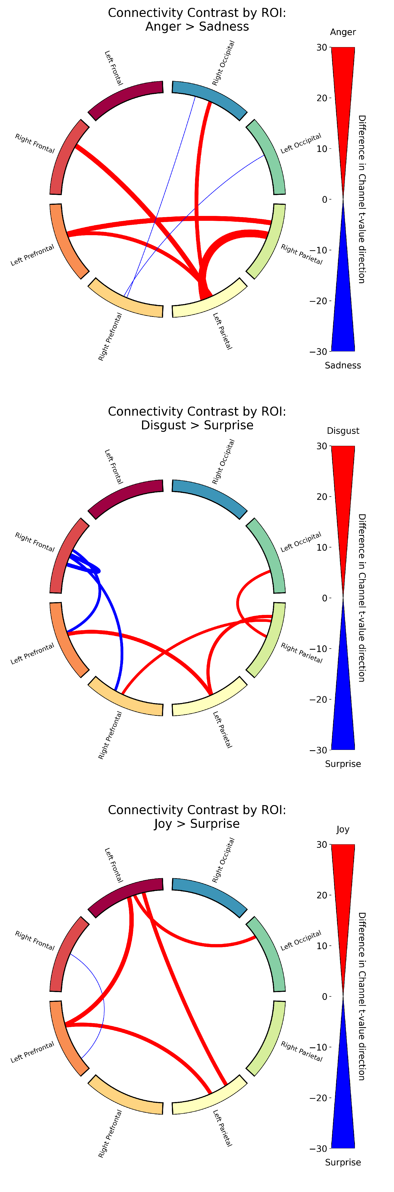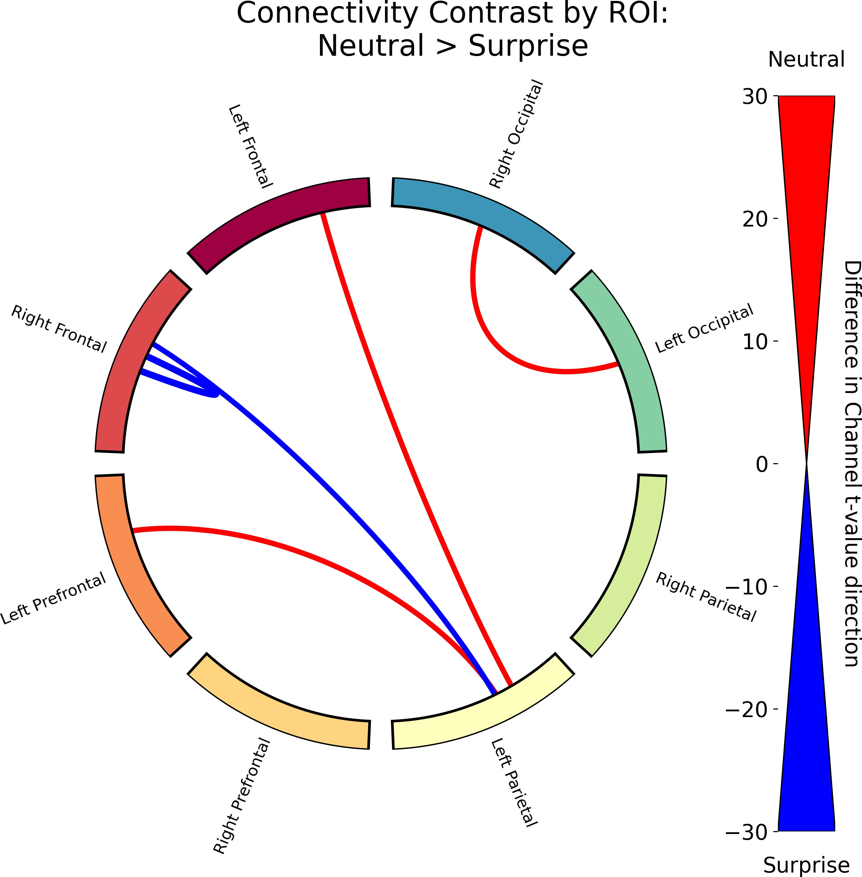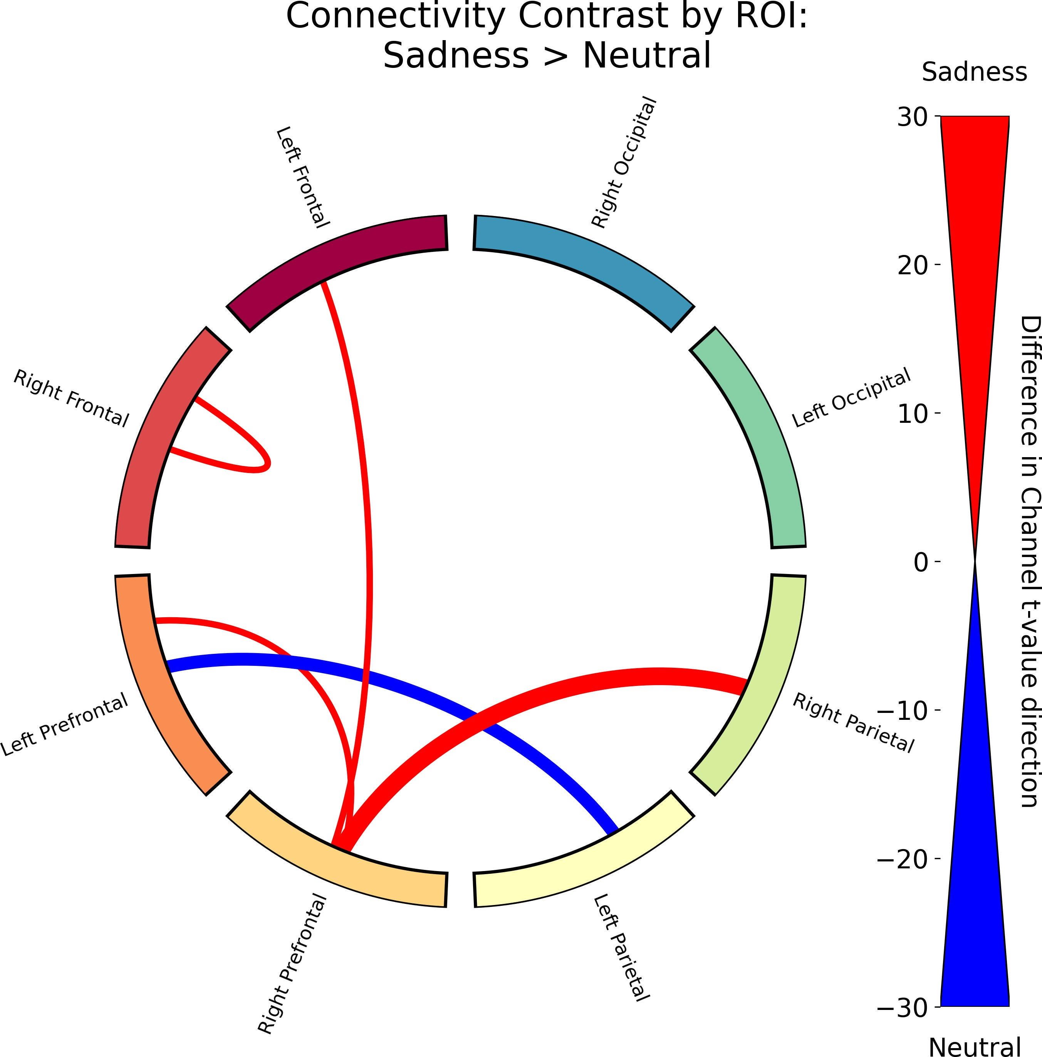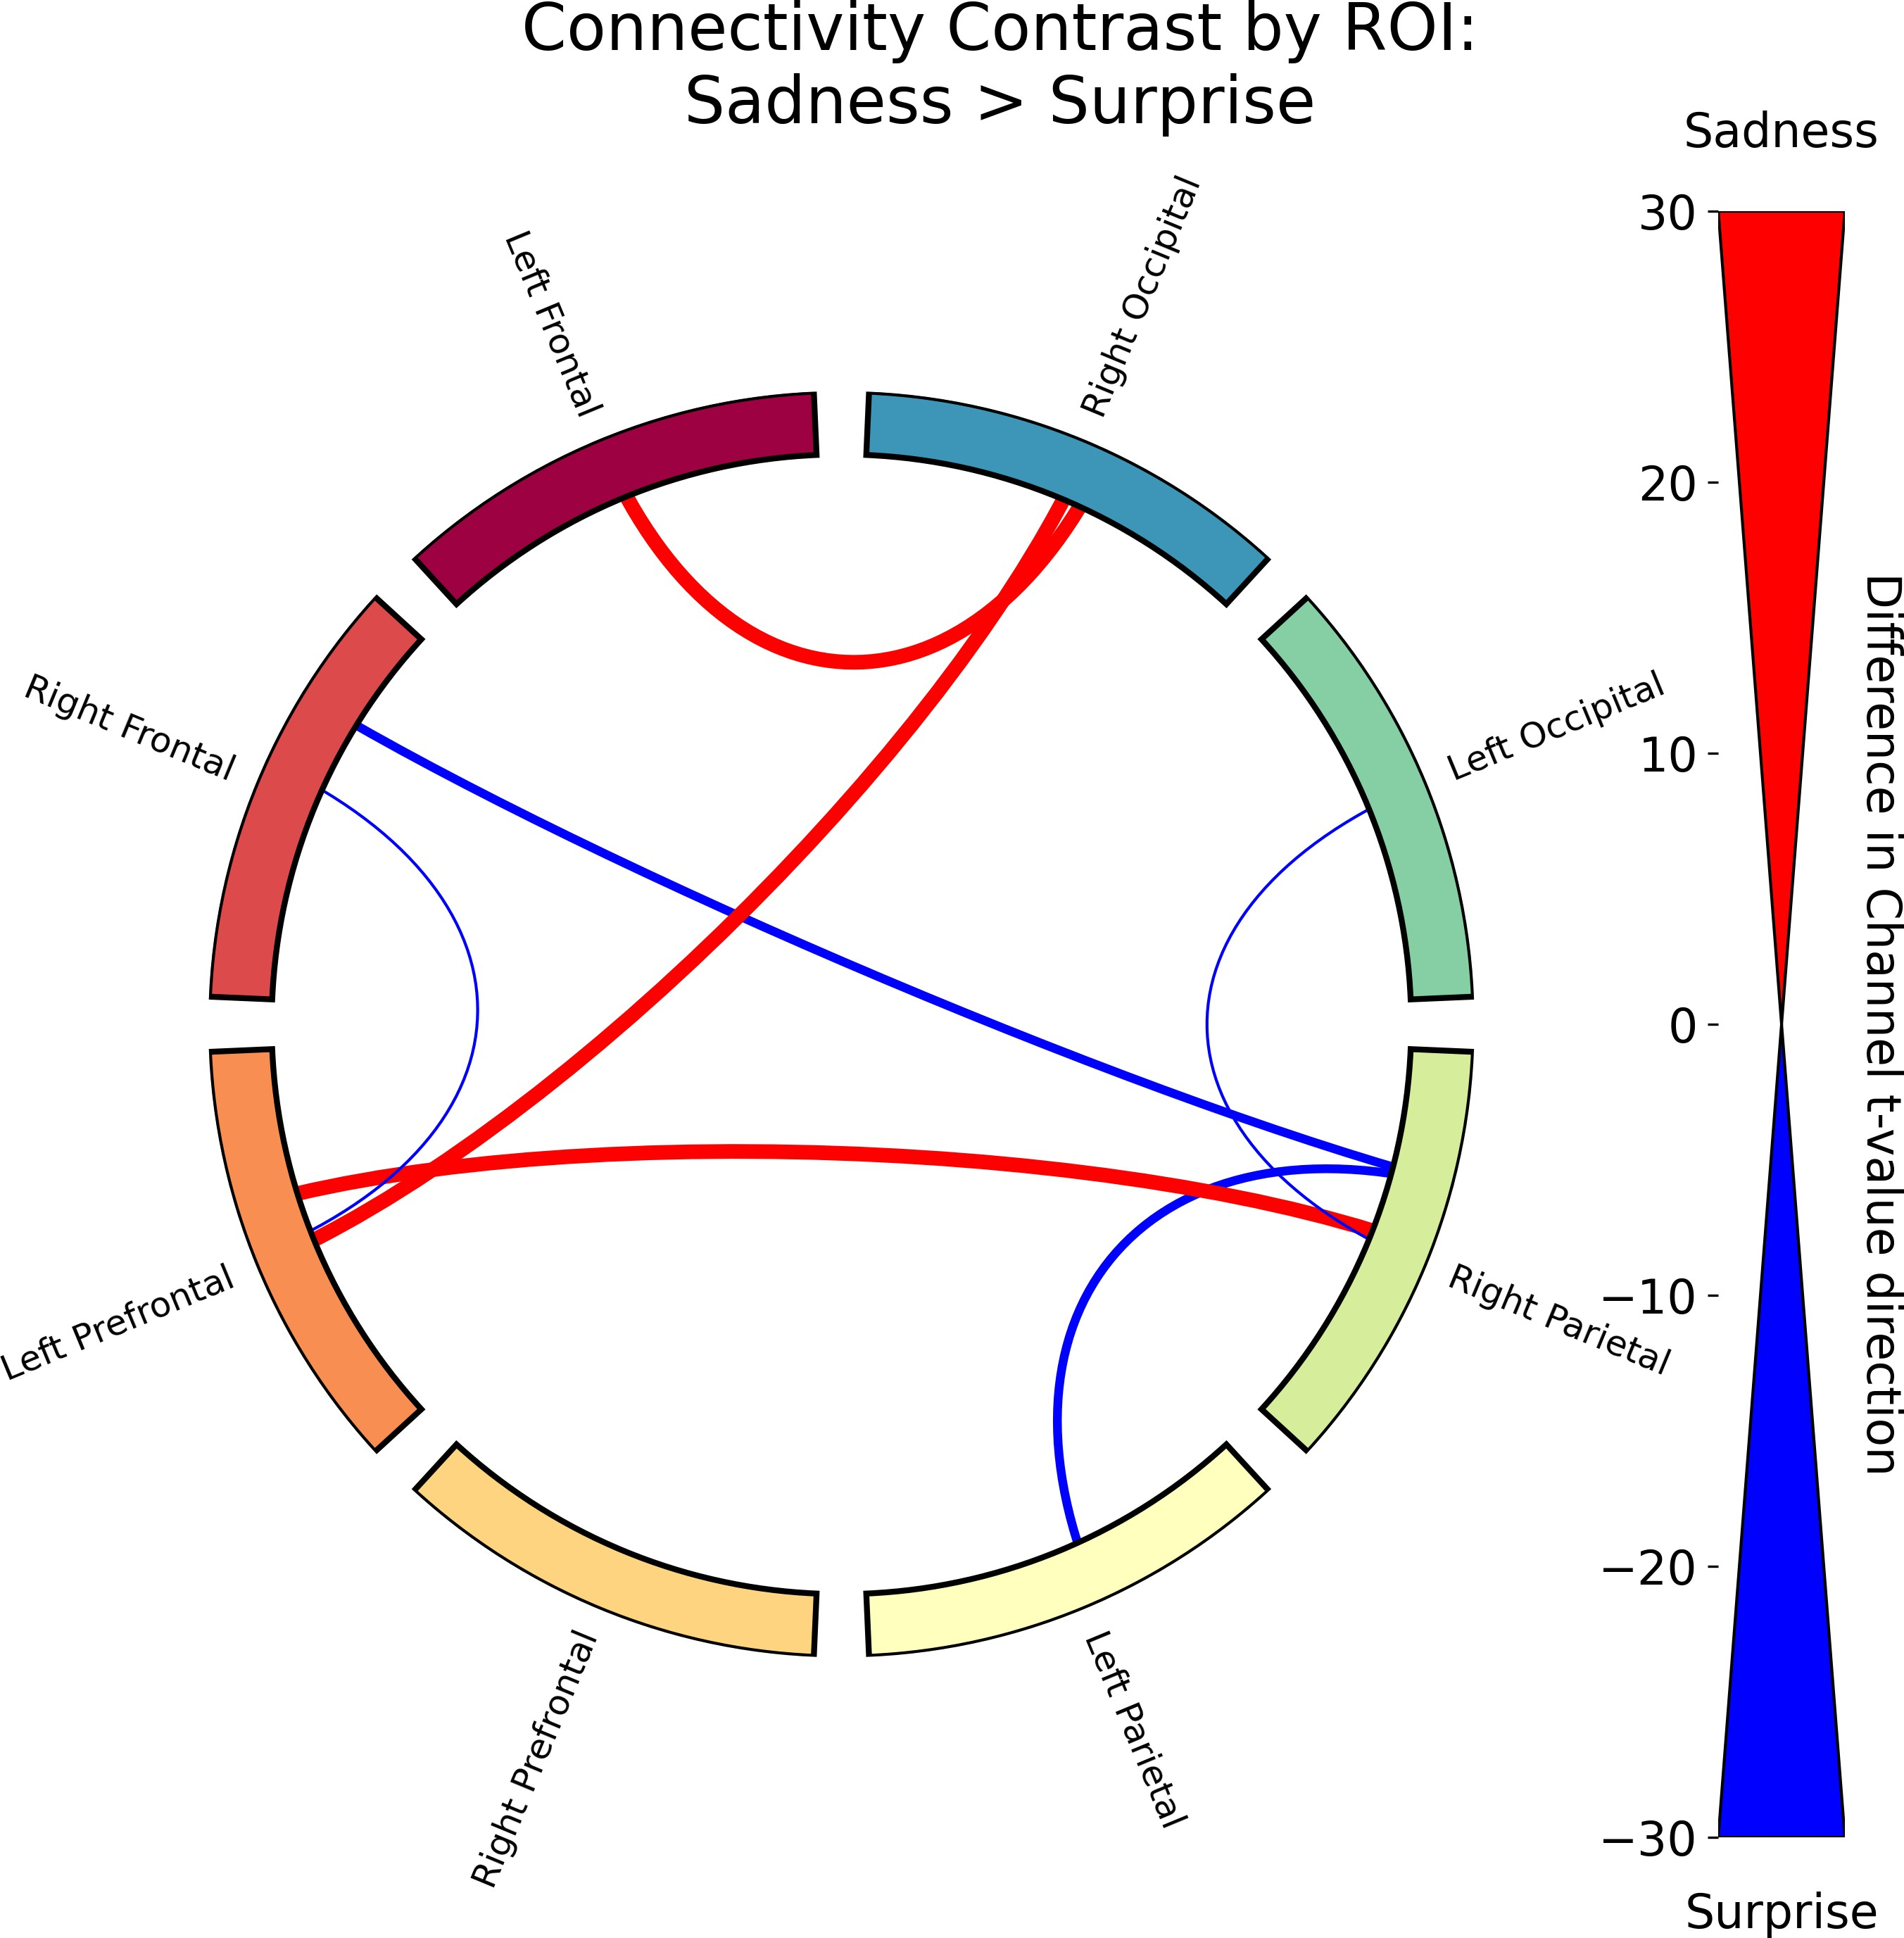

Figure B.1: Functional connectivity results for the rest of the contrasts. These are the rest of the contrasts that were not shown in 3.6.

Table B.1: Ratio of positive to negative *t*-values for each contrast. The ratio is calculated as Ratio = (Number of Positive *t*-values - Number of Negative *t*-values) / (Number of Positive *t*-values + Number of Negative *t*-values). For condition1 *>* condition2, a positive ratio indicates that condition1 has more positive *t*-values than condition2, while a negative ratio indicates the opposite.

Contrast

Ratio

|  |  |
| --- | --- |
| Real *>* Virtual | 0.632 |
| Joy *>* Fear | -0.797 |
| Joy *>* Anger | -0.323 |
| Joy *>* Disgust | 0.541 |
| Joy *>* Sadness | 0.622 |
| Joy *>* Neutral | 0.894 |
| Joy *>* Surprise | 0.976 |
| Fear *>* Anger | 0.345 |
| Fear *>* Disgust | 0.959 |
| Fear *>* Sadness | 0.865 |
| Fear *>* Neutral | 0.977 |
| Fear *>* Surprise | 0.966 |
| Anger *>* Disgust | 0.805 |
| Anger *>* Sadness | 0.709 |
| Anger *>* Neutral | 0.957 |
| Anger *>* Surprise | 0.897 |
| Disgust *>* Sadness | 0.099 |
| Disgust *>* Neutral | 0.677 |
| Disgust *>* Surprise | 0.172 |
| Sadness *>* Neutral | 0.311 |

Table B.1: Ratio of positive to negative *t*-values for each contrast. The ratio is calculated as Ratio = (Number of Positive *t*-values - Number of Negative *t*-values) / (Number of Positive *t*-values + Number of Negative *t*-values). For condition1 *>* condition2, a positive ratio indicates that condition1 has more positive *t*-values than condition2, while a negative ratio indicates the opposite.

Contrast

Ratio

|  |  |
| --- | --- |
| Sadness *>* Surprise | 0.400 |
| Neutral *>* Surprise | 0.077 |
| Real Joy *>* Real Fear | -0.284 |
| Real Joy *>* Real Anger | -0.546 |
| Real Joy *>* Real Disgust | 0.881 |
| Real Joy *>* Real Sadness | -0.390 |
| Real Joy *>* Real Neutral | 0.602 |
| Real Joy *>* Real Surprise | 0.306 |
| Real Joy *>* Virtual Joy | 0.400 |
| Real Joy *>* Virtual Fear | -0.882 |
| Real Joy *>* Virtual Anger | -0.985 |
| Real Joy *>* Virtual Disgust | -0.636 |
| Real Joy *>* Virtual Sadness | 0.161 |
| Real Joy *>* Virtual Neutral | 0.158 |
| Real Joy *>* Virtual Surprise | 0.624 |
| Real Fear *>* Real Anger | -0.254 |
| Real Fear *>* Real Disgust | 0.832 |
| Real Fear *>* Real Sadness | -0.016 |
| Real Fear *>* Real Neutral | 0.617 |
| Real Fear *>* Real Surprise | 0.400 |

Table B.1: Ratio of positive to negative *t*-values for each contrast. The ratio is calculated as Ratio = (Number of Positive *t*-values - Number of Negative *t*-values) / (Number of Positive *t*-values + Number of Negative *t*-values). For condition1 *>* condition2, a positive ratio indicates that condition1 has more positive *t*-values than condition2, while a negative ratio indicates the opposite.

Contrast

Ratio

|  |  |
| --- | --- |
| Real Fear *>* Virtual Joy | 0.395 |
| Real Fear *>* Virtual Fear | -0.578 |
| Real Fear *>* Virtual Anger | -0.880 |
| Real Fear *>* Virtual Disgust | 0.103 |
| Real Fear *>* Virtual Sadness | 0.525 |
| Real Fear *>* Virtual Neutral | 0.366 |
| Real Fear *>* Virtual Surprise | 0.779 |
| Real Anger *>* Real Disgust | 0.823 |
| Real Anger *>* Real Sadness | 0.115 |
| Real Anger *>* Real Neutral | 0.853 |
| Real Anger *>* Real Surprise | 0.739 |
| Real Anger *>* Virtual Joy | 0.858 |
| Real Anger *>* Virtual Fear | -0.482 |
| Real Anger *>* Virtual Anger | -0.914 |
| Real Anger *>* Virtual Disgust | 0.359 |
| Real Anger *>* Virtual Sadness | 0.507 |
| Real Anger *>* Virtual Neutral | 0.743 |
| Real Anger *>* Virtual Surprise | 0.659 |
| Real Disgust *>* Real Sadness | -0.792 |
| Real Disgust *>* Real Neutral | 0.306 |

Table B.1: Ratio of positive to negative *t*-values for each contrast. The ratio is calculated as Ratio = (Number of Positive *t*-values - Number of Negative *t*-values) / (Number of Positive *t*-values + Number of Negative *t*-values). For condition1 *>* condition2, a positive ratio indicates that condition1 has more positive *t*-values than condition2, while a negative ratio indicates the opposite.

Contrast

Ratio

|  |  |
| --- | --- |
| Real Disgust *>* Real Surprise | -0.400 |
| Real Disgust *>* Virtual Joy | -0.188 |
| Real Disgust *>* Virtual Fear | -0.959 |
| Real Disgust *>* Virtual Anger | -0.979 |
| Real Disgust *>* Virtual Disgust | -0.545 |
| Real Disgust *>* Virtual Sadness | -0.372 |
| Real Disgust *>* Virtual Neutral | -0.373 |
| Real Disgust *>* Virtual Surprise | -0.275 |
| Real Sadness *>* Real Neutral | 0.859 |
| Real Sadness *>* Real Surprise | 0.649 |
| Real Sadness *>* Virtual Joy | 0.694 |
| Real Sadness *>* Virtual Fear | -0.333 |
| Real Sadness *>* Virtual Anger | -0.825 |
| Real Sadness *>* Virtual Disgust | 0.036 |
| Real Sadness *>* Virtual Sadness | 0.308 |
| Real Sadness *>* Virtual Neutral | 0.489 |
| Real Sadness *>* Virtual Surprise | 0.885 |
| Real Neutral *>* Real Surprise | -0.480 |
| Real Neutral *>* Virtual Joy | -0.463 |
| Real Neutral *>* Virtual Fear | -0.937 |

Table B.1: Ratio of positive to negative *t*-values for each contrast. The ratio is calculated as Ratio = (Number of Positive *t*-values - Number of Negative *t*-values) / (Number of Positive *t*-values + Number of Negative *t*-values). For condition1 *>* condition2, a positive ratio indicates that condition1 has more positive *t*-values than condition2, while a negative ratio indicates the opposite.

Contrast

Ratio

|  |  |
| --- | --- |
| Real Neutral *>* Virtual Anger | -0.969 |
| Real Neutral *>* Virtual Disgust | -0.856 |
| Real Neutral *>* Virtual Sadness | -0.550 |
| Real Neutral *>* Virtual Neutral | -0.588 |
| Real Neutral *>* Virtual Surprise | -0.105 |
| Real Surprise *>* Virtual Joy | 0.267 |
| Real Surprise *>* Virtual Fear | -0.912 |
| Real Surprise *>* Virtual Anger | -0.928 |
| Real Surprise *>* Virtual Disgust | -0.200 |
| Real Surprise *>* Virtual Sadness | 0.123 |
| Real Surprise *>* Virtual Neutral | 0.058 |
| Real Surprise *>* Virtual Surprise | 0.432 |
| Virtual Joy *>* Virtual Fear | -0.867 |
| Virtual Joy *>* Virtual Anger | -0.979 |
| Virtual Joy *>* Virtual Disgust | -0.767 |
| Virtual Joy *>* Virtual Sadness | -0.203 |
| Virtual Joy *>* Virtual Neutral | -0.476 |
| Virtual Joy *>* Virtual Surprise | -0.150 |
| Virtual Fear *>* Virtual Anger | -0.686 |
| Virtual Fear *>* Virtual Disgust | 0.722 |

Table B.1: Ratio of positive to negative *t*-values for each contrast. The ratio is calculated as Ratio = (Number of Positive *t*-values - Number of Negative *t*-values) / (Number of Positive *t*-values + Number of Negative *t*-values). For condition1 *>* condition2, a positive ratio indicates that condition1 has more positive *t*-values than condition2, while a negative ratio indicates the opposite.

Contrast Ratio

Virtual Fear *>* Virtual Sadness 0.728

Virtual Fear *>* Virtual Neutral 0.877

Virtual Fear *>* Virtual Surprise 0.908

Virtual Anger *>* Virtual Disgust 0.870

Virtual Anger *>* Virtual Sadness 0.941

Virtual Anger *>* Virtual Neutral 0.938

Virtual Anger *>* Virtual Surprise 0.990

Virtual Disgust *>* Virtual Sadness 0.351

Virtual Disgust *>* Virtual Neutral 0.436

Virtual Disgust *>* Virtual Surprise 0.739 Virtual Sadness *>* Virtual Neutral -0.020 Virtual Sadness *>* Virtual Surprise 0.561 Virtual Neutral *>* Virtual Surprise 0.515

# Appendix C Memory Task

## ANOVA Results

Table C.1: Two-way ANOVA results for the effect of Face Type and Emotion and their interaction on the correct responses.

Intercept C(Face Type) C(Emotion)

C(Face Type):C(Emotion)

Residual

sum sq

261.07756

1.17722

0.73335

0.40872

df

1.00000

1.00000

6.00000

6.00000

*F*

PR(*>F* )

1764.58989 0.00000

7.95666

0.82610

0.46041

0.00481

0.54946

0.83797

710.47356 4802.00000

46

*Appendix C. Memory Task* 47

## Memory Task No Response Distribution

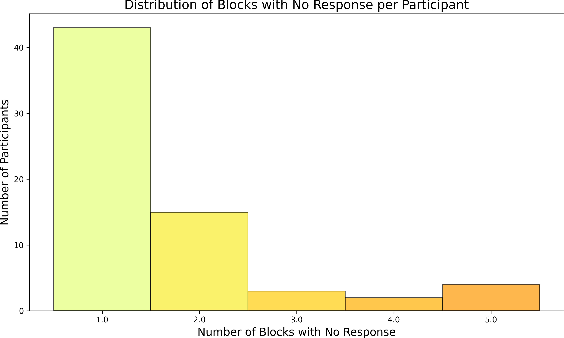

Figure C.1: Distribution of the number of no responses across the 56 blocks for each participant in the memory task.